

Knowsley Council
Strategic Housing Land
Availability Assessment
2023 Update
(Base date of 1 April 2023)

Published October 2023

Contents
1. Introduction 3
The 2023 Update 3
Call for sites 4
Site size threshold 4
2. Site Assessment Methodology 5
Suitability 5
Availability 5
Achievability 6
Constraint resolution 6
Density assumptions 7
Lead-in times and build-out rates 8
Sites with Planning Permission 9
Small Sites Allowance 10
Windfall allowance 10
3. The supply of sites to 2038 and five-year housing land supply position 12
4. Five-year housing land supply position 13
Appendix A: Housing Trajectory 15
Appendix B: Sites suggested for housing development during the “Call for Sites” exercise 16
Appendix C: Sites Removed from the SHLAA supply 31
Appendix D: Updated SHLAA Site Assessments 32
Appendix E: Housing Commitments Forecast 60
Appendix F: Local Plan Housing Allocations Forecast 61
Appendix G: SHLAA Sites Forecast 62

Disclaimer

The Strategic Housing Land Availability Assessment does not allocate land for residential development. It assesses whether sites are suitable for housing, provided they are not required for other purposes, in order to meet plan targets. It identifies constraints to development and considers how they might be overcome.

The inclusion of a site in the assessment should not be taken as an indication that it will be allocated or granted planning permission for housing, or any other form of development. All planning applications will be considered on their merits against policies in the development plan and the National Planning Policy Framework.

Introduction
  - Knowsley Council’s Strategic Housing Land Availability Assessment (SHLAA) is a key component of its evidence base to support the delivery of sufficient land for new housing to meet the borough’s need for more homes as guided by the housing policies within the Knowsley Local Plan Core Strategy.

  - This assessment is required by national planning policy as set out in the National Planning Policy Framework (NPPF). Paragraph 68 of the NPPF requires the Council to prepare a strategic housing land availability assessment to identify a sufficient supply and mix of sites, taking into account their availability, suitability, and likely economic viability.

  - According to the Government’s National Planning Practice Guidance (PPG), the primary role of a Strategic Housing Land Availability Assessment is to:

- Identify sites and broad locations with potential for development;
- Assess their development potential; and
- Assess their suitability for development and the likelihood of development coming forward (the availability and achievability).

  - This enables Knowsley Council to assess whether or not there is an adequate supply of land to meet the borough’s housing needs. Updating the assessment also enables the Council to update its housing trajectory, set out in Appendix A.

  - Further guidance is set out in the housing and economic land availability assessment section of PPG.

The 2023 Update
  - The 2023 SHLAA updates the Council's housing supply evidence to a base date of 1 April 2023 and provides an assessment of the ‘deliverable’ and ‘developable’ housing land supply in the borough. Consequently, any progress with the development of individual sites after 1 April 2023 and up to the preparation of this document, is not referred to.

  - The 2023 Update does though take account of any changes since 1 April 2022 and the last SHLAA Update, including new planning permissions, developments starting construction and the progress of sites already under construction. It also includes any suitable new sites which have been proposed as part of the 2023 ‘call for sites’ exercise and which are assessed as suitable for housing. The Update also removes sites that are no longer considered to have potential for housing; for example, sites secured for non-residential uses and sites which have since been developed.

Call for sites
  - From 1 March 2023 to 1 June 2023, stakeholders were invited to suggest sites for new housing development as part of a call for sites exercise. During this exercise, thirteen sites were received, which are listed in Appendix B. However, eleven of the thirteen sites are considered unsuitable because of the national or local importance of the sites’ designation, and the protection afforded by the Local Plan; for example, Green Belt sites without planning permission for housing. Sites considered unsuitable are determined as having no housing potential, are not identified in this assessment and are excluded from the SHLAA. The sites “Boundary Hotel” and “Fallows Way” have been assessed as suitable for residential development (in Appendix D) and included in the SHLAA.

Site size threshold
  - The assessment of sites takes account of recommendations contained in the PPG in respect of site size, which recommends that all sites and broad locations capable of delivering 5 or more dwellings should be considered. Consequently, the Update does not include sites:
- without planning permission with an estimated capacity of less than 5 dwellings; or
- with planning permission with a capacity of less than 5 dwellings.

  - Instead, this Update makes an allowance for small sites (as described in para. 2.24). Sites under construction with the benefit of planning permission for 5 or more dwellings are included, even when the remaining capacity, at 1 April 2023, is less than 5 dwellings.

Site Assessment Methodology
  - The purpose of the site assessment is to establish if the SHLAA sites carried over from the 2022 Update are ‘deliverable’, ‘developable’ or ‘not currently developable’. Ordinarily, new sites submitted as part of the call for sites exercise would also be the subject of a detailed assessment, but as explained already eleven of the thirteen sites submitted are unsuitable for potential housing.

  - To inform conclusions on the deliverability and developability of sites, information has been gathered from a variety of sources and recorded within a ‘site assessment form’ for each site, all of which are available to view in Appendix D. The information within the site assessment was used to establish the development potential of each site. The individual assumptions used for assessing whether a site is ‘deliverable’, ‘developable’ or ‘not currently developable’ are set down below.

Suitability
  - A site is suitable for housing development if it offers a suitable location for development and would contribute to the creation of sustainable mixed communities. When assessing a site’s suitability for residential development, the following factors have therefore been considered:

- Any local planning policy designations;
- Land contamination or poor ground condition, or instability;
- Flood risk;
- A hazardous installation, statutory consultation zone, or the buffer area for pipelines;
- Safe access; and
- Easy and convenient access to essential facilities by means other than the private car.

  - When a site is considered as ‘suitable’ for new residential development, it is colour-coded in the proforma as green, when it is ‘not suitable’ it is shaded in red.

Availability
  - A site is considered as ‘available’ for development when there is confidence that there are no legal or ownership problems, such as unresolved multiple ownerships, ransom strips tenancies or operational requirements of landowners. When forming conclusions about the availability of a site, the following factors were considered:

- Whether there was an extant planning consent and if so whether this had been implemented;
- Whether the site is in active use;
- Whether the site can be developed now; and
- Whether the site is free of ownership and tenancy issues.

  - Where a site was directly nominated by the landowner or developer in control of the site, in the absence of anything to suggest otherwise, it is assumed that the site is available for development. All sites were considered to be free from ownership or tenancy issues unless there was evidence/information to suggest the contrary.

  - When a site is considered as ‘available’ for new residential development, it is colour coded in the proforma as green, when it is likely to become available within 6-10 years it is shaded in orange, and 11-15 years have been shaded red.

Achievability
  - The PPG advises that a site is considered achievable for development where there is a reasonable prospect that the particular type of development will be developed on the site at a particular point in time. This judgement looks at the economic viability of a site, and the capacity of the developer to complete and let or sell the development over a certain period of time. In assessing achievability, the following factors were considered:

- Whether there is active developer interest in the site;
- Whether similar sites have been successfully developed in recent years; and
- Whether there are any known abnormal development costs.

  - When new residential development on a site is considered achievable, it is shaded green for strongly achievable, and shaded in orange when it is achievable; but when a site is anticipated to have issues about being achievable, which may be overcome in the future, it is shaded red.

Constraint resolution
  - Having assessed the suitability, availability, and achievability of each SHLAA site, a conclusion can be made on whether the site is ‘deliverable’, ‘developable’ or ‘not developable’. The PPG advises that where it is unknown when a site could be developed, then it should be regarded as not currently developable.

  - Where constraints are considered to be severe, and there are insufficient assurances to demonstrate if or when they can be overcome, the site must be recorded as ‘not developable’ due to the specified constraint. The following examples are reasons for sites being to be considered ‘not developable’ and constrained:

- Unsuitable due to loss of employment land;
- High risk of flooding;
- Unacceptable impacts/loss of open space, greenways, protected trees or areas of importance for wildlife;
- Suitable and access cannot be provided; and
- Steep topography.

  - In these circumstances the landowner / developer must demonstrate that any documented site-specific constraints can be overcome. When a site is ‘deliverable’ for new residential development, it is colour-coded in the proforma as green, when it is considered as ‘developable’ it is shaded in orange, and ‘not developable’ sites are shaded red.

Density assumptions
  - Assumptions are used to understand the development potential of each SHLAA site. Without specific intelligence suggesting otherwise, the gross to net ratios set out in Table 1 were applied to sites without planning permission, to take into account land needed for supporting infrastructure (e.g., internal road layouts and open space) and on-site constraints (e.g., flood risk and topography).
Table 1: Gross to net developable area assumptions
Gross Site Area | Net Developable Area
Less than 0.4 ha | 100% of gross area
0.4 ha to 2 ha | 90% of gross area
Sites over 2 ha | 75% of gross area

  - Local Plan Policy CS3: Housing Supply, Delivery and Distribution sets out a minimum density of 30 dwellings per hectare for residential development in Knowsley. Lower densities may be acceptable in circumstances where: a) the nature of the location in question allows for this; and b) it can be demonstrated that an identified local housing need will be met. However, to assess the housing potential of each site the following range of density multipliers continue to be applied to Knowsley’s SHLAA sites.

Table 2: Applied Densities
Housing Character | Applied Density (dwellings per hectare)
Low density suburban mix (detached and semi-detached) | 30
Low to medium density urban mix (town houses and semi-detached) | 40
Medium density urban mix (mainly town houses) | 50
High density urban mix (town houses and apartments) | 60
Apartments (up to six storey) | 70 and above

Lead-in times and build-out rates
  - Unless there is specific site intelligence suggesting otherwise, the indicative lead-in times in Table 3 were applied to sites when determining delivery. The lead-in times are based upon historic house monitoring records from the last 3 years. For clarification, the lead-in times represent the time taken from the date of a planning permission to the completion of the first dwelling on the site.
Table 3: Indicative lead-in times
Site Status | Below 50 dwellings | 50 dwellings and above
Under Construction | n/a | n/a
Full Planning Permission | 2 years | 2 years
Reserved Matters | 4 years | 2 years
Outline Planning Permission | 6 years | 4 years
Sites without Planning Permission | 7 years | 5 years
Stalled sites i.e., sites with planning permission, which have commenced but stalled. | 7 years | 5 years

  - A dwelling is said to be complete once it is ready for occupation. For new build dwellings, this is when the roof is in place, and the windows / doors are installed, as determined by an external observation by a Council Planning Officer during a site visit.

  - A dwelling is said to be under construction once the ground has been excavated in preparation for the laying of foundations. A dwelling is ‘under construction’ until it is ready for occupation and judged to be completed by a Council Planning Officer.

  - A general build-out rate of 20 dwellings per annum per developer is applied to sites up to 49 dwellings and 35 dwellings per annum per developer is applied to sites of 50 dwellings or more. Build-out rates will be kept under review in future SHLAA updates and could potentially be amended based upon evidence collected.

  - Other points to note regarding lead-in times and build-out rates are:
- Lead-in times and build-out rates are only calculated for sites that were identified as ‘deliverable’ or ‘developable’.
- Alternative build-out rates are applied where the Council has specific site intelligence for example, where the developer has notified the Council of its planned delivery rate, or in preceding years the Council have monitored alternative completion rates on sites already under construction.
- The Council has assessed the future delivery of sites with existing planning permissions using the information set out in the planning permission, the lead-in times set out Table 3 and build-out rates in para. 2.18

Sites with Planning Permission
  - The deliverability of sites with planning permission for 5 or more dwellings was considered in detail with officers from the Council’s Development Management and Housing Strategy teams, and where possible, the developer of the site. Intelligence on the progress of development sites is obtained from site visits by the Council’s Planning Policy team to ascertain whether development is under construction or is complete.

  - In accordance with the definition of a deliverable site in the NPPF, only sites which are available now, offer a suitable location for development now, and are achievable with a realistic prospect of delivery within five years are deemed deliverable and contribute to the borough’s five-year housing land supply. The definition and purpose of the five-year housing land supply is set out in national planning practice guidance.

  - Sites with outline planning permission, allocated in the development plan or identified on a brownfield register with a potential capacity of 5 or more dwellings are considered deliverable where there is clear evidence that housing completions will begin within five years, for example where a developer has indicated that they are to submit a reserved matters application and deliver homes in the short term.

  - Where a developer / landowner has not indicated that they are to submit a reserved matters application and deliver homes in the short term, the Council has assessed the future delivery of the site using the information set out in the planning permission and the historic lead-in times and build-out rates set out in Table 3 and para. 2.18. This approach is intended to accord with the Government’s NPPG for housing and economic land availability assessments, by using benchmarks and assumptions based on evidence of past trends for development lead-in times and build-out rates.

Small Sites Allowance
  - An allowance of 12 homes per annum is included in the SHLAA to reflect capacity from small sites that are currently not in the planning system. Small sites are those with a capacity of less than the SHLAA threshold of 5 homes. The allowance rate is the average number of residential completions on small sites in the borough over the five-year period 1 April 2018 – 31 March 2023, as shown in Table 4.

  - This shows that 59 homes were completed on small sites in this period, which equates to an average of 12 homes per annum, representing around 1.5% of all completions.

Table 4: Completion of dwellings on sites with planning permissions for less than 5 dwellings
Year | Total number of small and large site completions (gross) | Total small site completions on Sites Under 5 Dwellings (gross) | Small site completions on Sites Under 5 Dwellings as a proportion of total completions
2018-2019 | 838 | 10 | 1.2%
2019-2020 | 1,090 | 15 | 1.4%
2020-2021 | 836 | 5 | 0.6%
2021-2022 | 498 | 12 | 2.4%
2022-2023 | 730 | 10 | 1.4%
Five-year total | 3992 | 52 | 1.3%
Five-year average | 798 | 10 | 1.3

Windfall allowance
  - NPPF paragraph 71 states where an allowance is to be made for windfall sites as part of anticipated supply, there should be compelling evidence that they will provide a reliable source of supply. The NPPF defines windfall sites as sites not specifically identified in the development plan. Consequently, windfall sites are those sites developed for housing that were not previously identified as available for residential development within the Local Plan process, i.e., allocated or in the SHLAA. They are normally sites that have been previously developed for another use that unexpectedly become available for residential development, for example an industrial unit that is no longer fit for its intended use, or residential conversions from offices.

  - The Local Plan, paragraph 5.20 states: For clarity, an allowance for windfall sites will not be considered to be part of the housing land supply in Knowsley, which will be clearly set out in evidence base and monitoring reports. Nevertheless, the new housing development arising from these sites will be monitored on an annual basis and will be counted towards annual and overall targets for net housing delivery. In the 2016 SHLAA the Council did not attribute a windfall allowance to its housing supply because of the small number of average annual completions historically, which is the approach taken in this update too.

  - Table 5 confirms the small number of completions on windfall sites over the last five years, illustrating there has been an average of 14 dwellings per annum, which represents 1.8% of all completions.

Table 5: Completion of dwellings on windfall sites

Year | Total windfall completions | Windfall completions as a proportion of total completions
2018-2019 | 10 | 1.2%
2019-2020 | 35 | 3.2%
2020-2021 | 7 | 0.8%
2021-2022 | 13 | 2.6%
2022-2023 | 6 | 0.8%
Five-year total | 71 | 1.8%
Five-year average | 14 | 1.8%

The supply of sites to 2038 and five-year housing land supply position
  - The total supply of sites over the next 15 years to 2038 is summarised in Table 6 below. This table does not represent a target for the number of homes to be built, nor is it an estimate of the number of homes that will be built. It provides an indication of the total capacity for homes in the borough on sites and broad locations, currently identified as suitable for development. Further sites will be added in future updates, which will be undertaken annually.
Table 6 Housing land supply to 2038, as at 1 April 2023
Supply type | 2023-28  (0-5 years) | 2028-33  (6-10 years) | 2033-38  (11-15 years) | Total  2023-2038
Commitments from planning permissions | 735 | 8 | 0 | 743
Local Plan Housing Allocations | 1,566 | 968 | 0 | 2,534
SHLAA sites | 751 | 696 | 63 | 1,510
Small sites windfall allowance (12dpa x 5) | 60 | 60 | 60 | 180
Total | 3112 | 1,732 | 123 | 4,967

  - The comprehensive forecast schedule of housing commitments, housing allocations, and SHLAA sites is set out in Appendix E, F and G. This sets out the position as at the base date of 1 April 2023.

Five-year housing land supply position
  - The purpose of the 5-year housing land supply is to provide an indication of whether there are sufficient sites available to meet the housing requirement set out in adopted strategic policies for the next 5 years.

  - The strategic housing policies in the Knowsley Local Plan Core Strategy have been reviewed within the last 5 years and found not to need updating. Therefore, in accordance with paragraph 73 of the NPPF, the borough’s deliverable housing supply is calculated against the housing requirement figure identified in adopted strategic housing policy. Consequently, the 5-year housing land supply figure in the borough for 2023/2024 is 450 homes per annum.

  - The NPPF includes an annual Housing Delivery Test for all local planning authorities. The Housing Delivery Test measures whether planned requirements (or, in some cases, local housing need) have been met over the last 3 years. The results for Knowsley are set out in Table 7 below and show that Knowsley has a strong recent record of housing delivery. It is noted that the 2022 SHLAA resulted in the delivery of 410% of the homes required. As a result, the Council is only required to include a 5% buffer on its five-year housing land supply, which is the minimum buffer for authorities.

Table 7: Housing Delivery Test results
 | Homes required | Homes delivered
2019-2020 | 230 | 1097
2020-2021 | 174 | 810
2021-2022 | TBC | 499
Total | TBC | 2406
Housing Delivery Test score |  | TBC%

  - The housing delivery test is usually released annually in January but there has been a delay this year due to the proposed reforms to national policy. However, it is felt Knowsley’s delivery percentage is unlikely to drop particularly from the 410% in the 2022 Update. As a result, the Council is only required to include a 5% buffer on its five-year housing land supply, which is the minimum buffer for LPAs.

  - Table 8 calculates the 5-year supply requirement and the Council’s five-year supply position. It shows that the Council can demonstrate a 6.57 years’ supply of deliverable housing land.
Table 8: Calculating the 5-year supply position
- Basic requirement | The borough’s housing requirement of 450 per annum multiplied by 5 | 2,250
- 5% buffer | As required by NPPF paragraph 74 | 113
- Total requirement |  | 2,363
- Number of homes identified in years 0-5 | Via commitments, allocations and SHLAA sites (Table 6) | 3,112
- Annual requirement over 5 years | C divided by 5 | 473
- Number of years supply | D divided by E | 6.57

Appendix A: Housing Trajectory

Appendix B: Sites suggested for housing development during the “Call for Sites” exercise

Representor name & status | Site address | Assessment | Included in SHLAA?
Amy James WSP (Agent) | Land North of Church Road, Halewood, L26 3UA | The site is in the Green Belt and its development would be contrary to national Green Belt policy. | No.
Graham Lamb, Pegasus Group (Agent) | Home Farm Road, Knowsley Village,  Land south and east of Home Farm Road,  Knowsley,  Prescot,  L34 0EB | The site is identified as ‘safeguarded land’ in Policy SUE1 of the Knowsley Local Plan Core Strategy. The site will be considered for housing development as part of a future review of the Local Plan. | No. It is worth noting that the site was also excluded from the 2016 and 2022 SHLAA.
Eleanor Rawsthorne, Harworth Group (Owner) | Land north of Sarum Road and Naylorsfield Drive, Huyton | The site is in the Green Belt and its development would be contrary to national Green Belt policy. | No.
Paul Johnson, Frank Marshall & Co. (Agent) | Land at School Lane and Knowsley Lane, Knowsley | The site is in the Green Belt and its development would be contrary to national Green Belt policy. | No.
Tony Crowney (Owner) | Land north of Wheat Hill Road, Huyton | The site is in the Green Belt and its development would be contrary to national Green Belt policy. | No.
Hyacynth Cabiles, NHS Property  Services (owner) | Boundary Hotel, Pilch Lane, Huyton, Liverpool, L14 0JG | See Appendix D: Updated SHLAA Site Assessments for appraisal. | Yes.
Savills on behalf of the Knowsley Estate (owner) | Land south of The Paddocks | The site is in the Green Belt and its development would be contrary to national Green Belt policy. | No.
Savills on behalf of the Knowsley Estate (owner) | Land north of Knowsley Lane | The site is in the Green Belt and its development would be contrary to national Green Belt policy. | No.
Savills on behalf of the Knowsley Estate (owner) | Land south of the A580 – East Lancashire Road  (east of Knowsley Park) | The site is in the Green Belt and its development would be contrary to national Green Belt policy. | No.
Savills on behalf of the Knowsley Estate (owner) | Land north of Mill Lane | The site is in the Green Belt and its development would be contrary to national Green Belt policy. | No.
Mrs Honor M Wood (owner) | Land after 6 Lancaster Avenue | The site is in the Green Belt and its development would be contrary to national Green Belt policy. | No. The site was also excluded from the 2022 SHLAA.
Pegasus Group on behalf of VUR Village Trading (owner) | Village Hotels, Fallows Way, Whiston | See Appendix D: Updated SHLAA Site Assessments for appraisal. | Yes.
Simon Halliwell, Paddock Johnson (Agent) | Land at Ash Lane, Widnes WA8 8JT | The site is in the Green Belt and its development would be contrary to national Green Belt policy. | No.

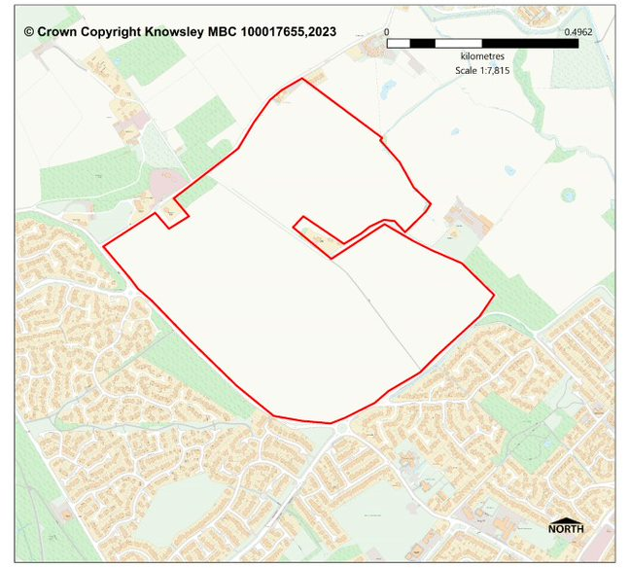
Figure 1: Land North of Church Road, Halewood, L26 3UA

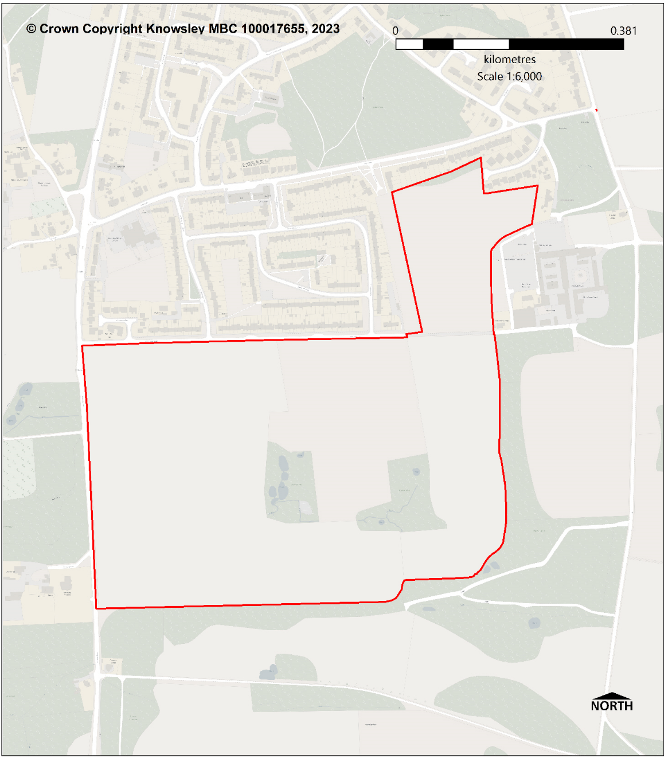
Figure 2: Home Farm Road, Knowsley Village

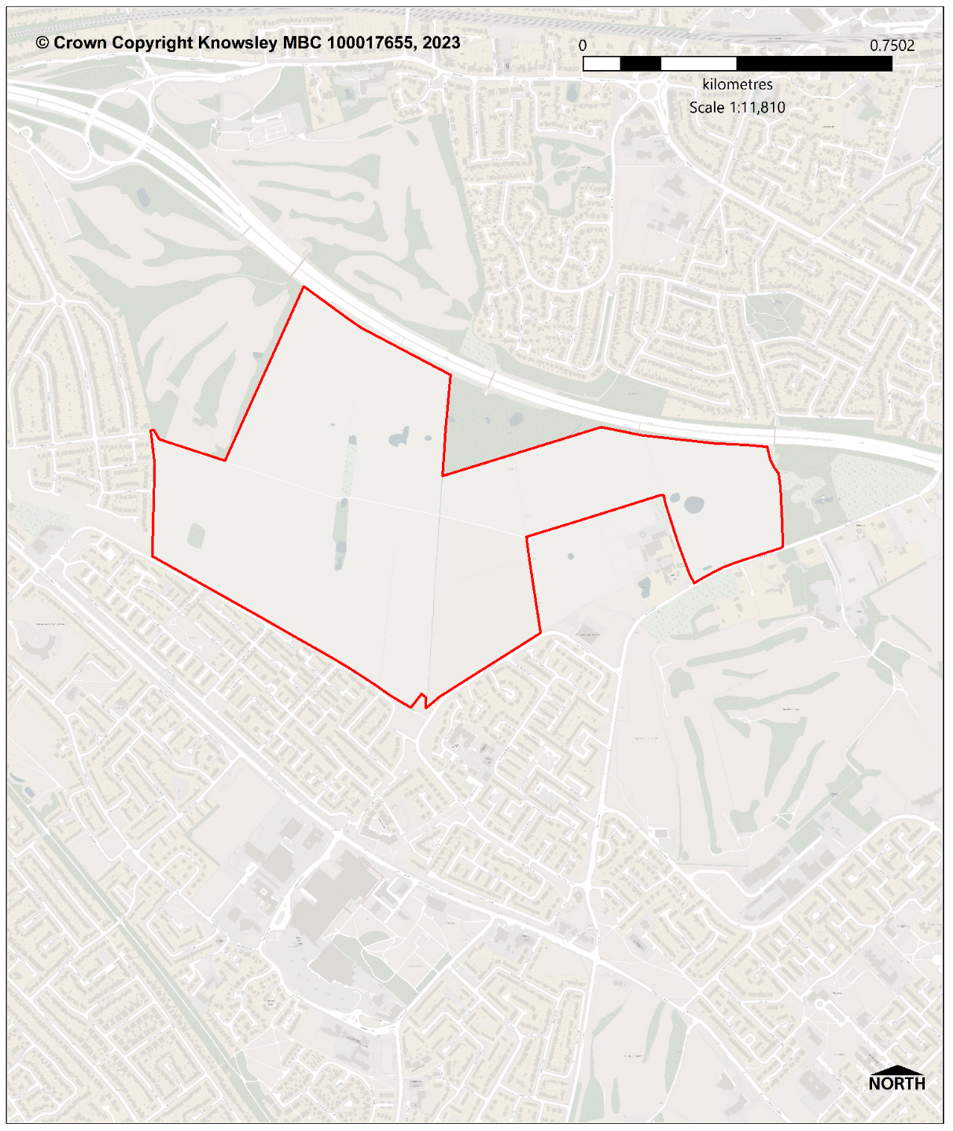
Figure 3: Land north of Sarum Road and Naylorsfield Drive, Huyton

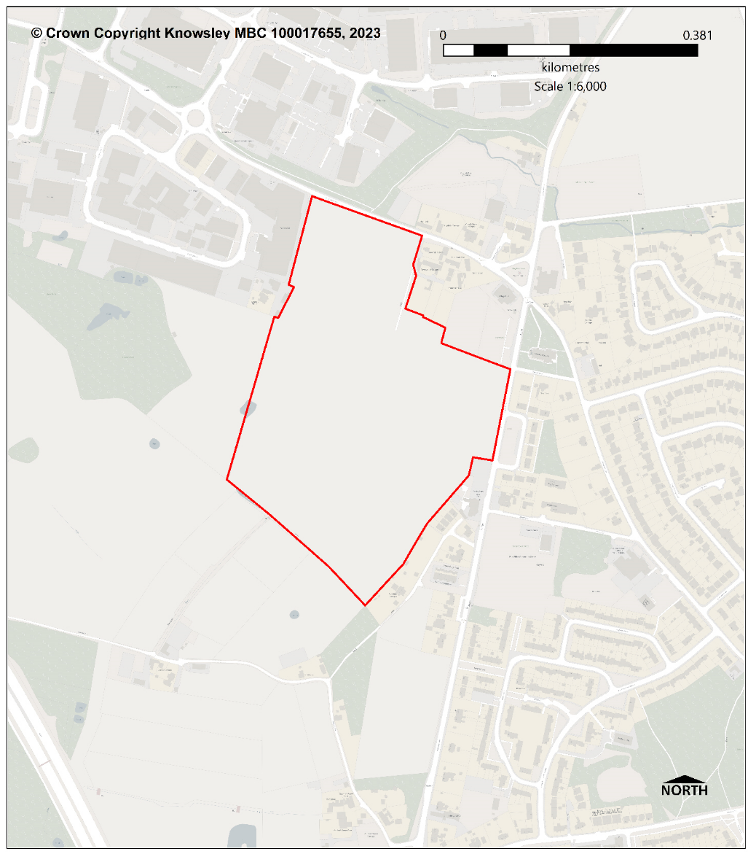
Figure 4: Land at School Lane and Knowsley Lane, Knowsley

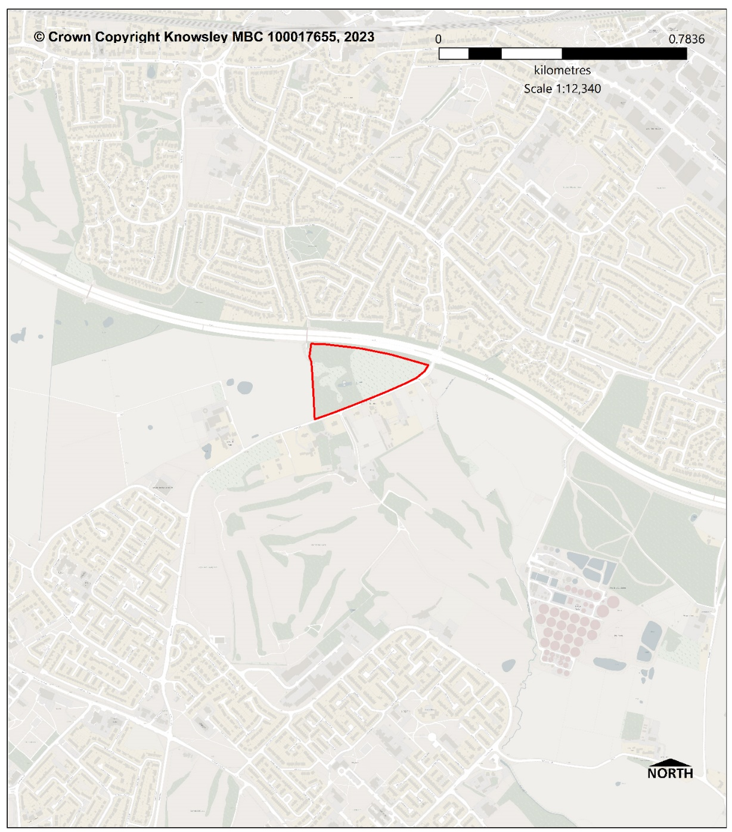
Figure 5: Land north of Wheat Hill Road, Huyton

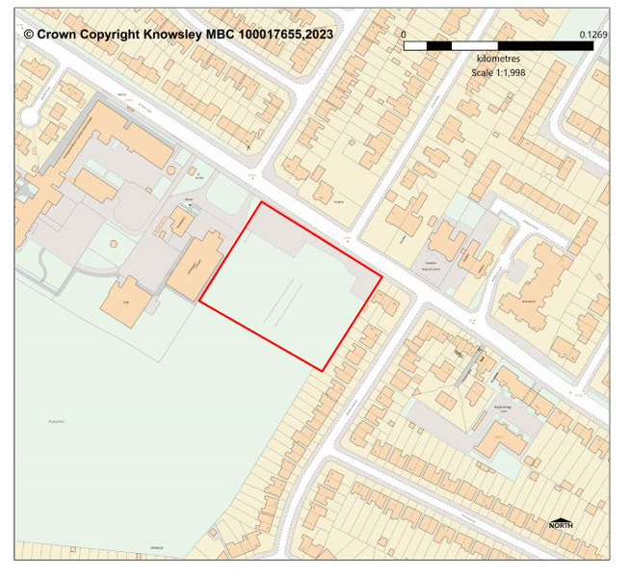
Figure 6: Boundary Hotel, Pilch Lane, Huyton, Liverpool, L14 0JG

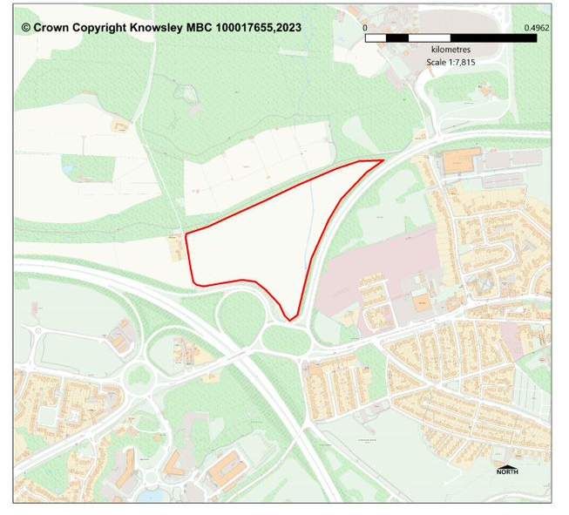
Figure 7: Land south of The Paddocks

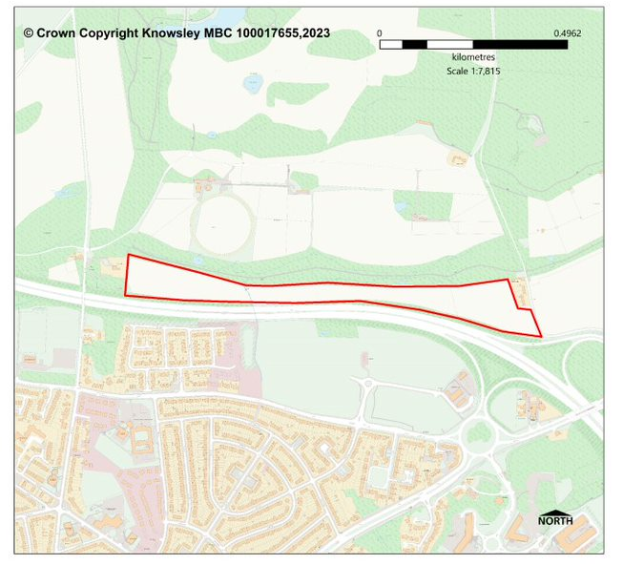
Figure 8: Land north of Knowsley Lane

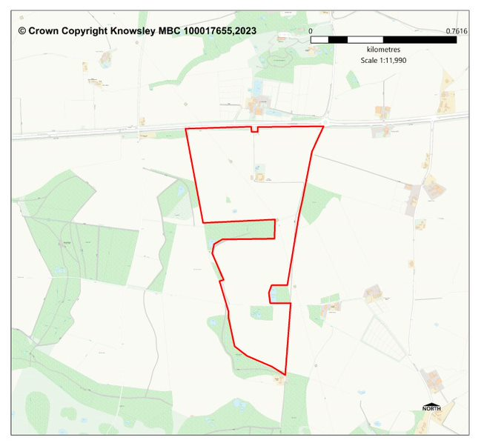
Figure 9: Land south of the A580 – East Lancashire Road

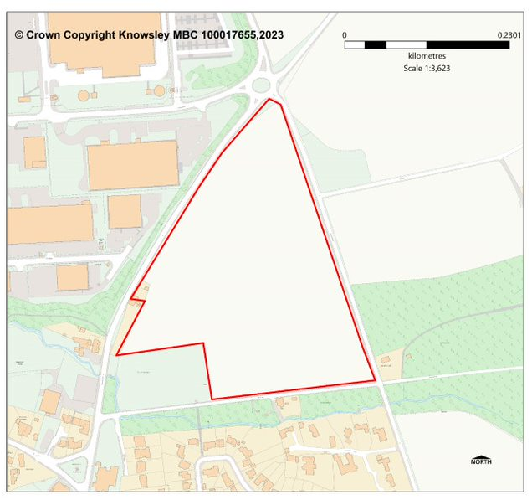
Figure 10: Land north of Mill Lane

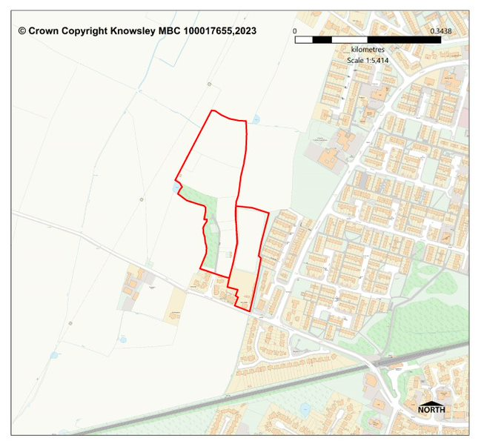
Figure 11: Lancaster Avenue

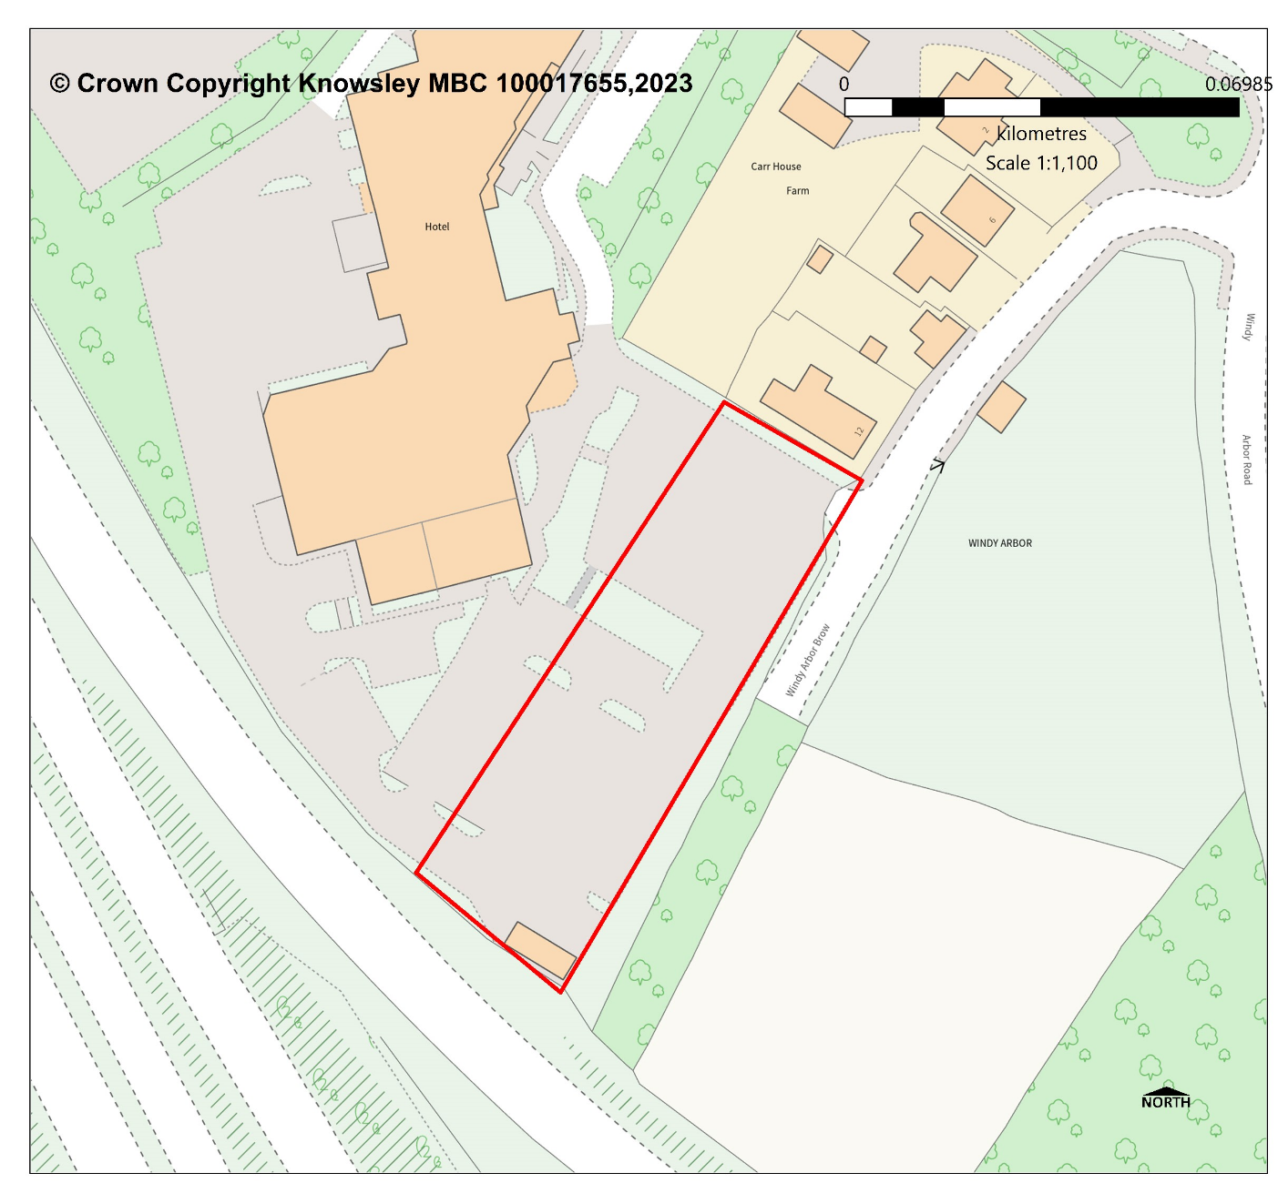
Figure 12: Fallows Way, Whiston, Liverpool, L35 1RZ

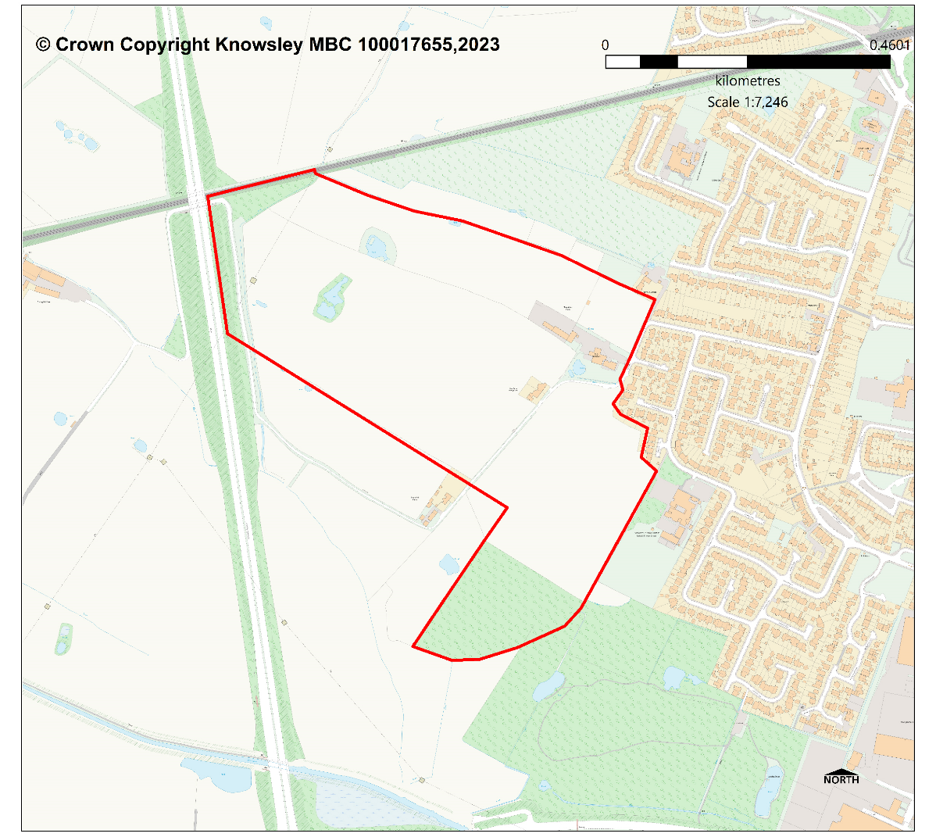
Figure 13: Land at Ash Lane, Widnes WA8 8JT

Appendix C: Sites Removed from the SHLAA supply

SHLAA site ID | Site Name | Rationale for removing from SHLAA supply
K0461 | Roughwood Drive, Kirkby | Following the granting of planning permission 17/00201/FUL the development is now complete.
K0224 | St Jude's Vicarage 168 Roundhey | Following the granting of planning permission 20/00048/FUL the development is now complete
K0451 | Former Longview School Playing Field, Primrose Drive | Following the granting of planning permission 20/00099/FUL, the site is now under construction and the wider site is being delivered.
K0228 | Willis House | Following correspondence from the owner it was advised that Willis House is a fully operational site with no current strategic intentions to close or relocate it.
K0423 | Land Off Knowl Hey Road, Halewood | A reassessment has concluded the site does not meet the site size threshold of 5 dwellings, and is excluded from the SHLAA.

Appendix D: Updated SHLAA Site Assessments

Site Reference: K0042
Site Name | Adj. to Farmers Arms Dinas Lane, Huyton
Post Code
Ward | Page Moss
Land type | Greenfield
Size (gross) | 0.155 ha.
Net Developable Area | 0.155 ha.
Potential Yield | 5 dwellings
Development Trajectory | 6-10 years
Description | Vacant land
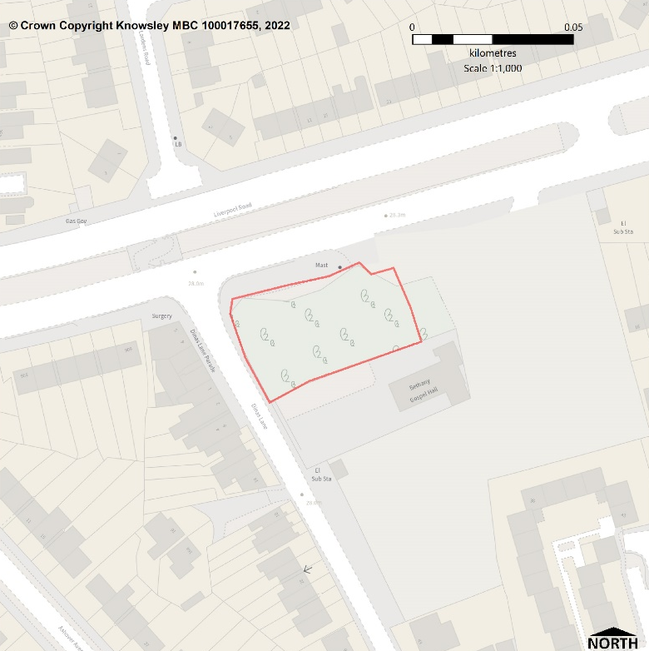

ASSESSMENT OF SUITABILITY, AVAILABILITY AND ACHIEVABILITY
Suitability: Suitable for housing
This site is within an existing residential area and accessible by different modes of travel. It abuts Dinas Lane and the A57 Liverpool Road, along which there is a bus route. Page Moss district centre is approximately 200m to the east, there is a GP within 500m and there are four primary schools within 1000m.
Availability: The site is considered to become available in 6-10 years
The necessary infrastructure is available within the locality and there are no known legal or ownership issues and the site is considered to be available. However, market interest appears to be currently low.
Achievable: The site is achievable
The site is likely to be financially viable to develop.
Conclusion: The site is developable
This is a vacant site, which was previously developed but where the remains of the permanent structure or fixed surface structure have blended into the landscape. The site is free from constraint, with prominent frontage along the A57 Liverpool Road. Consequently, the site has excellent access to facilities and services. There are no policy or known physical constraints that would make the site unsuitable for housing.

Site Reference: K0053
Site Name | 266 - 277 Boode Croft, Stockbridge, Huyton
Ward | Stockbridge
Land type | Greenfield
Size (gross) | 0.18 ha.
Net Developable Area | 0.18 ha.
Potential Yield | 5 dwellings
Development Trajectory | 6-10 years
Description | Informal open space
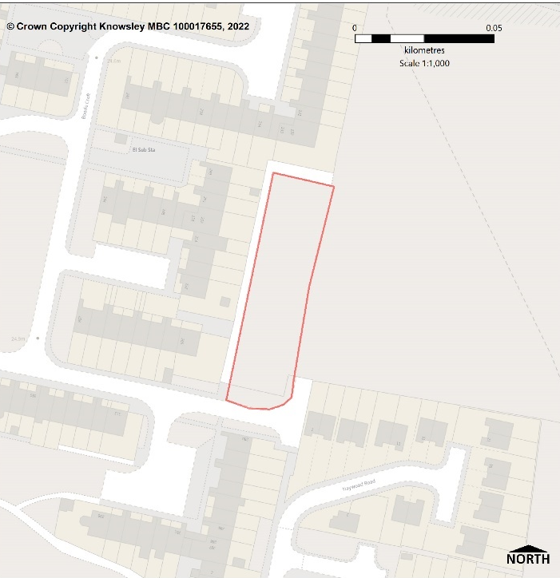

ASSESSMENT OF SUITABILITY, AVAILABILITY AND ACHIEVABILITY
Suitability: Suitable for housing
This site is within a Primarily Residential Area and accessible by different modes of travel with a bus route nearby on Haswell Drive. In addition, there is a GP, two Primary schools and Stockbridge Village district centre within 1000m.
Availability: The site is considered to become available in 6-10 years
The necessary infrastructure is available within the locality and there are no known legal or ownership issues and the site is considered to be available. However, market interest appears to be currently low.
Achievable: The site is achievable
The site is likely to be financially viable to develop.
Conclusion: The site is Developable
This cleared housing site is currently vacant and functions as informal open space within a Primarily Residential Area in the development plan. Although the site was previously developed, it is greenfield because the remains of the permanent structure or fixed surface structure have blended into the landscape. However, its development for housing would result in an extension of the development form to the west and north. The site is owned by a registered provider and there are no planning policy or known physical constraints that would make it unsuitable for housing.

Site Reference: K0061
Site Name | Land at Pod 10 (west) Boode Court, Stockbridge, Huyton
Ward | Stockbridge
Land type | Greenfield
Size (gross) | 0.224 ha.
Net Developable Area | 0.224 ha
Potential Yield | 7 dwellings
Development Trajectory | 6-10 years
Description | Informal open space
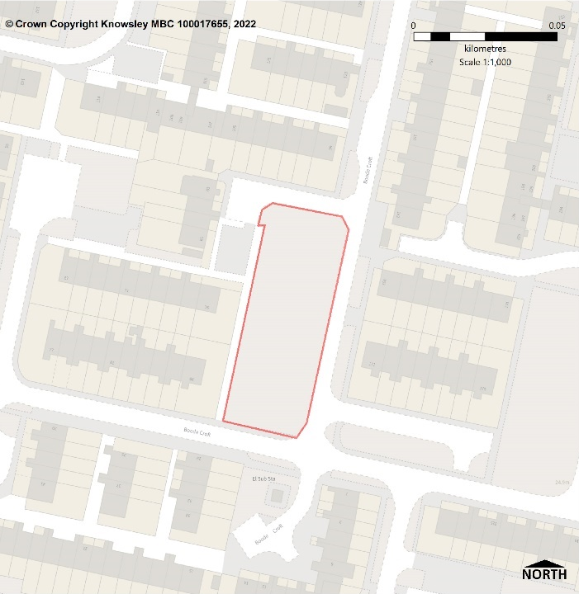

ASSESSMENT OF SUITABILITY, AVAILABILITY AND ACHIEVABILITY
Suitability: Suitable for housing
This site is within a Primarily Residential Area and accessible by different modes of travel with a bus route nearby on Haswell Drive. There is a GP, two Primary schools and Stockbridge Village District Centre within 1000m.
Availability: The site is considered to become available in 6-10 years
The necessary infrastructure is available within the locality and there are no known legal or ownership issues and the site is considered to be available. However, market interest appears to be currently low.
Achievable: The site is achievable
The site is likely to be financially viable to develop.
Conclusion: The site is Developable
This cleared housing site is currently vacant and functions as informal open space within a Primarily Residential Area in the development plan. Although the site was previously developed it is greenfield because the remains of the permanent structure or fixed surface structure have blended into the landscape. The site is owned by a registered provider and there are no planning policy or known physical constraints that would make it unsuitable for housing.

Site Reference: K0062
Site Name | Land at Pod 10 (East) Boode Court, Stockbridge, Huyton
Ward | Stockbridge
Land type | Greenfield
Size (gross) | 0.222 ha.
Net Developable Area | 0.222 ha
Potential Yield | 7 dwellings
Development Trajectory | 6-10 years
Description | Informal open space
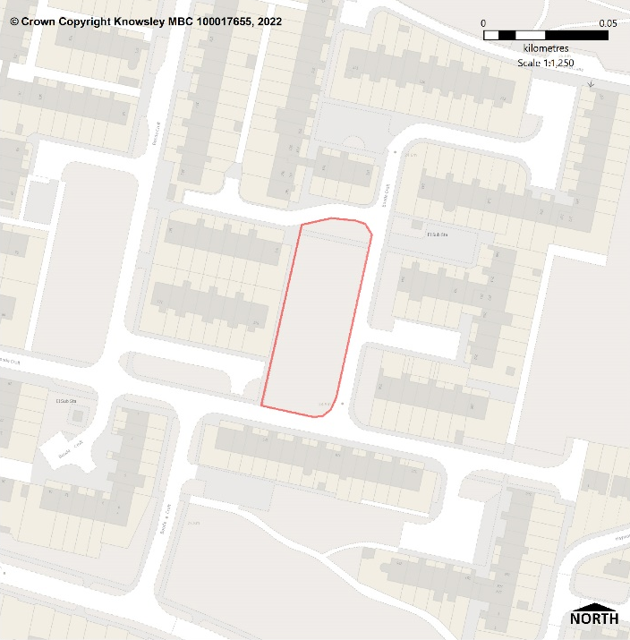

ASSESSMENT OF SUITABILITY, AVAILABILITY AND ACHIEVABILITY
Suitability: Suitable for housing
This site is within a Primarily Residential Area and accessible by different modes of travel with a bus route nearby on Haswell Drive. There is a GP, two Primary schools and Stockbridge Village District Centre within 1000 m.
Availability: The site is considered to become available in 6-10 years
The necessary infrastructure is available within the locality and there are no known legal or ownership issues and the site is considered to be available. However, market interest appears to be currently low.
Achievable: The site is achievable
The site is likely to be financially viable to develop.
Conclusion: The site is Developable
This cleared housing site is currently vacant and functions as informal open space within a Primarily Residential Area in the development plan. Although the site was previously developed it is greenfield because the remains of the permanent structure or fixed surface structure have blended into the landscape. However, it is considered to be suitable for residential dwellings. The site is owned by a registered provider and there are no planning policy or known physical constraints that would make the site unsuitable for housing.

Site Reference: K0074
Site Name | Land at Wheathill Road, Huyton
Ward | Roby
Land type | Greenfield
Size (gross) | 0.22 ha.
Net Developable Area | 0.22 ha.
Potential Yield | 7 dwellings
Development Trajectory | 11-15 years
Description | Vacant land
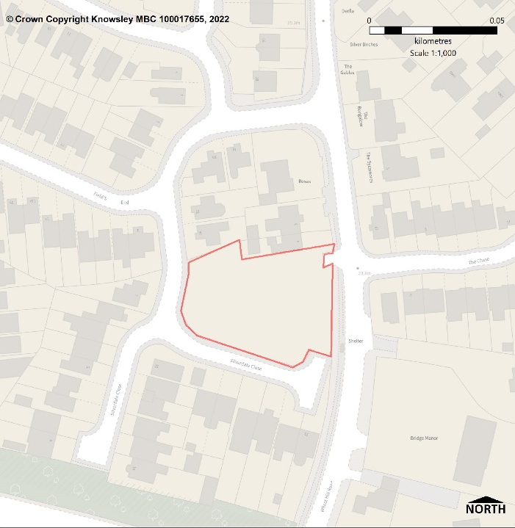

ASSESSMENT OF SUITABILITY, AVAILABILITY AND ACHIEVABILITY
Suitability: Suitable for housing
This site is within a Primarily Residential Area and accessible by different modes of travel. The site bounds Wheat Hill Road and there is a bus stop on the frontage of the site with services running to the retail, commercial and employment offer in Huyton Town Centre and the train station. There is one GP within approx. 600m and two within 1000m of the site.
Availability: The site is considered to become available in 11-15 years
The necessary infrastructure is available within the locality but there could be ownership issues.
Achievable: Not currently achievable
This site might have uncertain viability due to ownership issues and whilst the site is not considered achievable currently, it is anticipated the issue may be overcome in the future.
Conclusion: The site is Developable
This vacant site is in a built-up area and appears to function as a residential garden. It is overgrown with semi-mature trees and hedges, with a highway access point off Wheat Hill Road. There are no planning policy or known physical constraints that would make the site unsuitable for housing. However, ownership issues mean that it is not considered to be suitable and developable for residential dwellings until the period 11-15 years.

Site Reference: K0076
Site Name | Pod 11 Hollow Croft, Huyton
Ward | Stockbridge
Land type | Brownfield
Size (gross) | 0.329 ha.
Potential Yield | 10 dwellings
Net Developable Area | 10 dwellings
Development Trajectory | 6-10 years
Description | Car park and associated landscaping
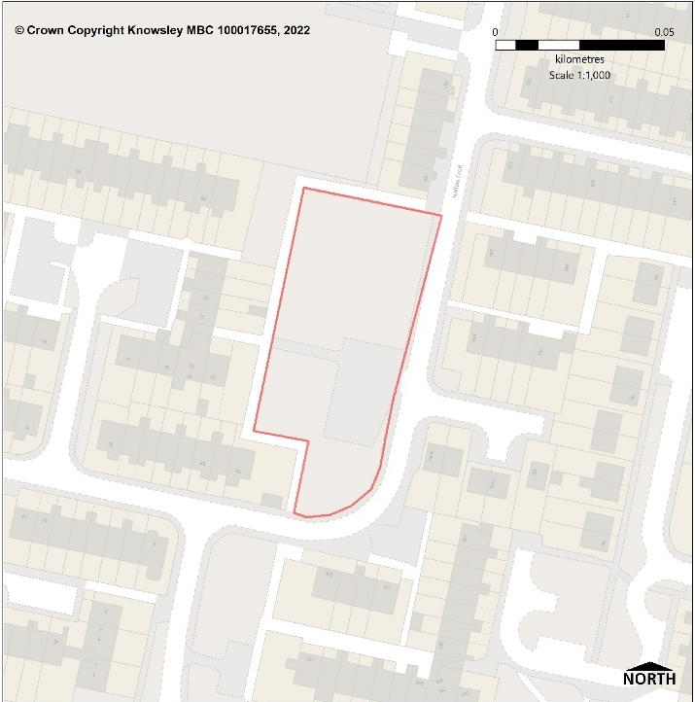

ASSESSMENT OF SUITABILITY, AVAILABILITY AND ACHIEVABILITY
Suitability: Suitable for housing
This site is within a Primarily Residential Area and accessible by different modes of travel with a bus route nearby on Haswell Drive. There is a GP, two primary schools and Stockbridge Village district centre within 1000m.
Availability: The site is considered to become available in 6-10 years
The necessary infrastructure is available within the locality and there are no known legal or ownership issues and the site is considered to be available immediately. However, market interest appears to be currently low
Achievable: The site is achievable
The site is likely to be financially viable to develop.
Conclusion: The site is Developable
The site comprises soft landscaping and hardstanding for car parking, however, it is considered to be suitable for residential dwellings. The site is owned by a registered provider and there are no planning policy or known physical constraints that would make it unsuitable for housing.

Site Reference: K0084
Site Name | Land to the north of Brook Hey Drive, Kirkby
Ward | Northwood
Land type | Greenfield
Size (gross) | 0.286 ha.
Net Developable Area | 0.286 ha
Potential Yield | 10 dwellings
Development Trajectory | 6-10 years
Description | Residential
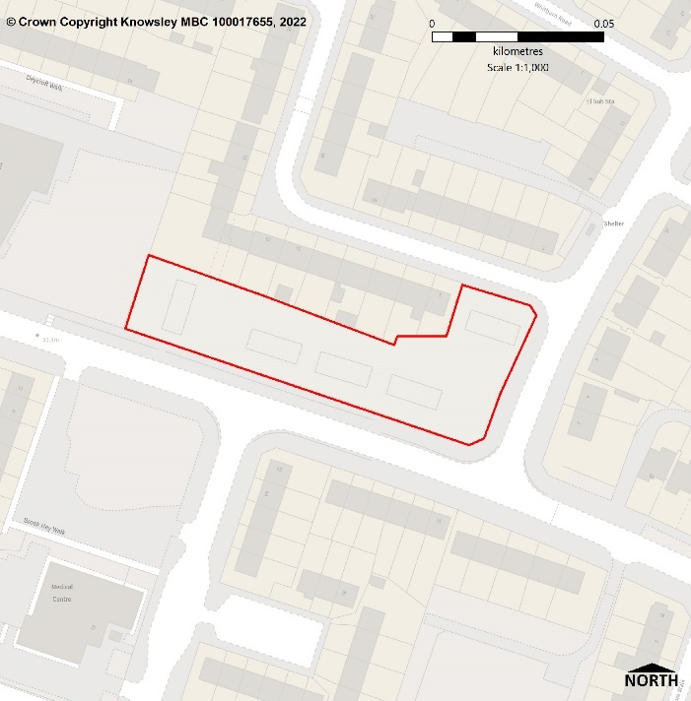

ASSESSMENT OF SUITABILITY, AVAILABILITY AND ACHIEVABILITY
Suitability: Suitable for housing
This site is in an existing residential area and accessible by different modes of travel, with a bus route operating on the adjacent Brook Hey Drive. There is also a GP, two Primary schools and one secondary school within 500m, whilst Kirkby town centre is approximately 600m to the south west.
Availability: The site is considered to become available in 6-10 years
The necessary infrastructure is available within the locality, but there are legal or ownership issues; therefore, the site is not considered to be available immediately.
Achievable: The site is achievable
There has previously been developer interest in this site, and it is likely to be financially viable to develop.
Conclusion: The site is Developable
The site currently benefits from full planning permission for 10 dwellings (21/00354/FUL) and development is classified as under construction, however, it has stalled during 2022-2023.

Site Reference: K0088
Site Name | Pod 9 Boode Croft, Stockbridge, Huyton
Ward | Stockbridge
Land type | Greenfield
Size (gross) | 0.585 ha.
Net Developable Area | 0.5265
Potential Yield | 16 dwellings
Development Trajectory | 6-10 years
Description | Informal open space
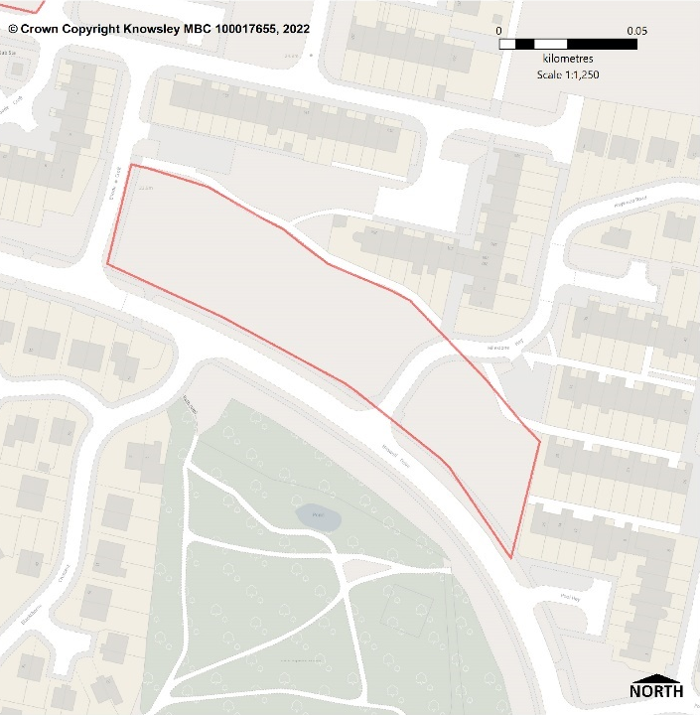

ASSESSMENT OF SUITABILITY, AVAILABILITY AND ACHIEVABILITY
Suitability: Suitable for housing
This site is within a Primarily Residential Area and accessible by different modes of travel. The site bounds Haswell Drive, along which there is a bus route with services running to Huyton village. There is also access to facilities and services with a GP, three primary schools and Stockbridge Village district centre within 600m.
Availability: The site is considered to become available in 6-10 years
The necessary infrastructure is available within the locality and there are no known legal or ownership issues and the site is considered to be available. However, market interest appears to be currently low.
Achievable: The site is achievable
The site is likely to be financially viable to develop.
Conclusion: The site is Developable
This cleared housing site is currently vacant and functions as informal open space within a Primarily Residential Area in the development plan. Although it was previously developed it is greenfield because the remains of the permanent structure or fixed surface structure have blended into the landscape. However, it is considered to be suitable for residential dwellings. The site is owned by a registered provider and there are no planning policy or known physical constraints that would make it unsuitable for housing.

Site Reference: K0096
Site Name | Former St. Clem’s Croxteth Lane, Stockbridge, Huyton
Ward | Stockbridge
Land type | Greenfield
Size (gross) | 1.815 ha.
Net Developable Area | 1.6335 ha.
Potential Yield | 49 dwellings
Development Trajectory | 11-15 years
Description | Urban greenspace
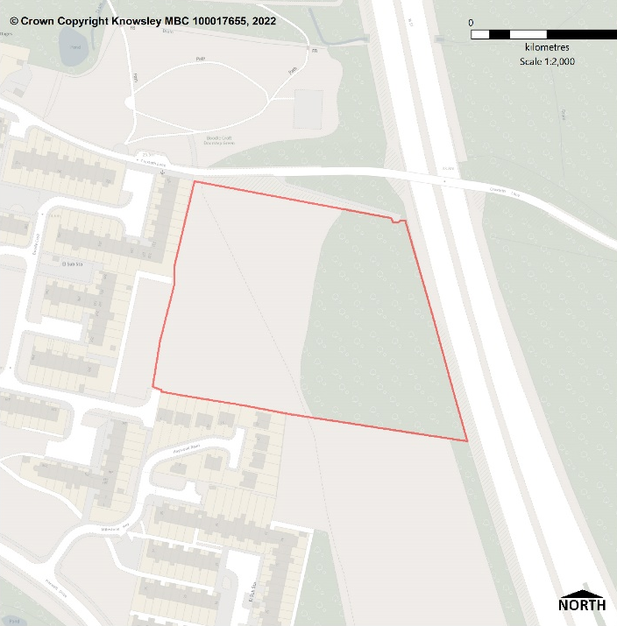

ASSESSMENT OF SUITABILITY, AVAILABILITY AND ACHIEVABILITY
Suitability: Suitable for housing
This site is designated as Urban Greenspace via the Local Plan and currently functions as informal open space. This site is in an accessible location, close to bus stops located on Haswell Drive and Knowsley Lane. It is approximately 0.7 miles from Stockbridge Village district centre, Meadow Park School and Stockbridge Village primary school are close by, and a GP is also located southeast of the site.
Availability: The site is considered to become available in 11-15 years.
The necessary infrastructure is available within the locality, but provision to the site will need to be confirmed with the relevant utility companies. There are no known legal or ownership issues, but market interest appears to be currently low.
Achievable: The site is achievable
There are no known constraints to achievability and the site is likely to be financially viable to develop.
Conclusion: The site is Developable
This site is owned by Knowsley Council and was formerly occupied by a school. However, it is no longer required for education or sporting provision. The development of the site for housing would result in an extension of the urban form however the M57 provides a defensible boundary to prevent urban sprawl. Having said that, the loss of greenspace would need to be assessed. There are no other planning policy or known physical constraints that would make the site unsuitable for housing. In the absence of developer interest in and an assessment of the loss of greenspace the site is considered developable but not deliverable.
Site Reference: K0108
Site Name | Land at Copthorne Walk, Kirkby
Ward | Whitefield
Land type | Greenfield
Size (gross) | 0.23 ha.
Net Developable Area | 0.23 ha
Potential Yield | 13 dwellings
Development Trajectory | 0-5 years
Description | Informal open space
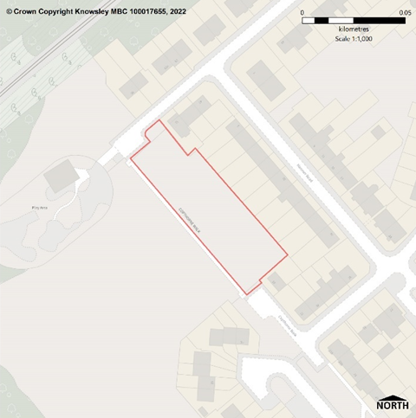

ASSESSMENT OF SUITABILITY, AVAILABILITY AND ACHIEVABILITY
Suitability: Suitable for housing
This site is within a Primarily Residential Area and accessible by different modes of travel with a bus route nearby on Whitefield Drive and Kirkby train station approximately 700m away. There is also access to facilities and services with one GP and three primary schools within 1000m, whilst Kirkby town centre is approximately 1 mile away.
Availability: The site is available
The site is under construction.
Achievable: The site is achievable
The site is under construction.
Conclusion: The site is Deliverable
The site forms part of a larger site, with full planning permission for 15 dwellings (20/00695/FUL) that is now under construction. The K0108 element of the application site would provide 13 dwellings comprising terraced dwellings and apartments.

Site Reference: K0163
Site Name | Former Huyton College, Huyton Hey, Huyton
Ward | St. Gabriel’s
Land type | Brownfield
Size (gross) | 0.54 ha.
Net Developable Area | 0.54 ha
Potential Yield | 40 dwellings
Development Trajectory | 0-5 years
Description | Vacant land
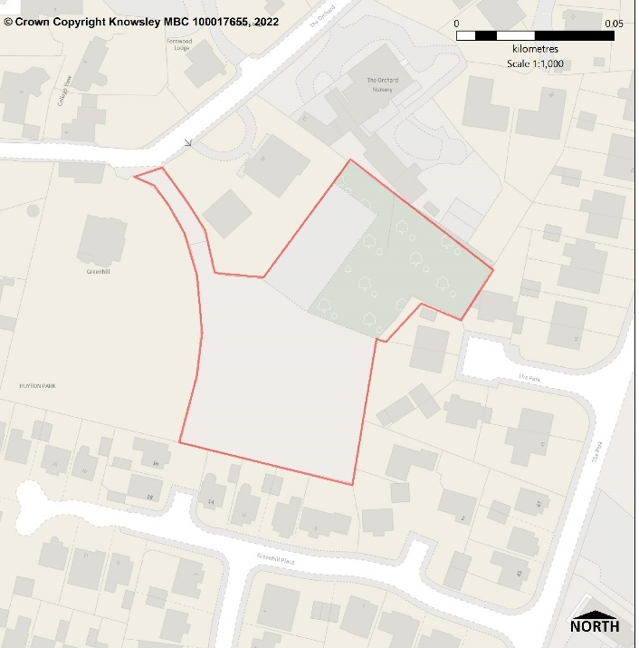

ASSESSMENT OF SUITABILITY, AVAILABILITY AND ACHIEVABILITY
Suitability: Suitable for housing
This site is in an existing residential area and accessible by different modes of travel. It is close to Huyton train station and within 500m is Huyton bus station or bus stops along Tarbock Road. Huyton village, one GP and two primary schools are within approximately 500m.
Availability: The site is available
The necessary infrastructure is available within the locality and there are no known legal or ownership issues. Therefore the site is considered to be available immediately.
Achievable: The site is achievable
There is current developer interest in this site and it is likely to be financially viable to develop.
Conclusion: The site is Deliverable
This site formerly housed a school sports hall (now demolished) and tennis
Courts. There are no planning policy or known physical constraints that would make the site unsuitable for housing, although consideration to access and potential impact on The Orchard Conservation Area is required. There is planning permission (22/00263/FUL) for 40 apartments but to date the site is not under construction.

Site Reference: K0175
Site Name | Land at Custley Hey, Stockbridge, Huyton
Ward | Stockbridge
Land type | Greenfield
Size (gross) | 0.188 ha.
Net Developable Area | 0.188 ha
Potential Yield | 6 dwellings
Development Trajectory | 6-10 years
Description | Informal open space
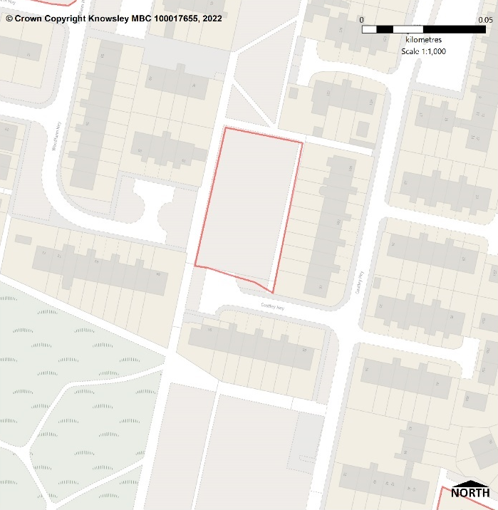

ASSESSMENT OF SUITABILITY, AVAILABILITY AND ACHIEVABILITY
Suitability: Suitable for housing
This site is within a Primarily Residential Area and accessible by different modes of travel. The site bounds Haswell Drive, along which there is a bus route with services running to Huyton village. There is also access to facilities and services with a GP, three primary schools and Stockbridge Village district centre within 600m.
Availability: The site is considered to become available in 6-10 years
The necessary infrastructure is available within the locality and there are no known legal or ownership issues and the site is considered to be available. However, market interest appears to be currently low.
Achievable: The site is achievable
The site is likely to be financially viable to develop.
Conclusion: The site is Developable
The site is vacant and currently functions as informal open space within a Primarily Residential Area in the development plan. The site is owned by a registered provider and there are no planning policy or known physical constraints that would make the site unsuitable for housing.

Site Reference: K0201
Site Name | Little Moss Hey, Stockbridge, Huyton
Ward | Stockbridge
Land type | Greenfield
Size (gross) | 5.4 ha.
Net Developable Area | 4.05
Potential Yield | 162 dwellings
Development Trajectory | 0-10 years
Description | Urban greenspace
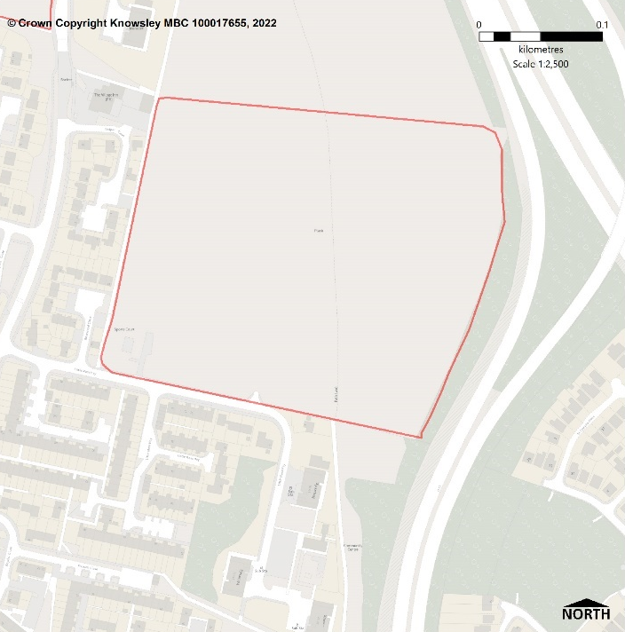

ASSESSMENT OF SUITABILITY, AVAILABILITY AND ACHIEVABILITY
Suitability: Suitable for housing
This site is designated as Urban Greenspace via the Local Plan and currently functions as informal open space. It is in an accessible location, close to bus stops located on Haswell Drive and is approximately 800m from Stockbridge Village district centre including a GP. Meadow Park School and Stockbridge Village Primary School are also close by.
Availability: The site is available
The necessary infrastructure is available within the locality and there are no known legal or ownership issues and the site is considered to be available immediately.
Achievable: The site is achievable
The site is likely to be financially viable to develop.
Conclusion: The site is Deliverable
This Council owned site was formerly used for a comprehensive school, which was vacated in the early 1990s. Although the site was previously developed it is greenfield because the remains of the permanent structure or fixed surface structure have blended into the landscape.

The site is no longer required for education or sporting provision and is surplus to the Council’s requirements however the loss of greenspace would need to be assessed.

The development of the site for housing would result in an extension of the urban form but the M57 provides a defensible boundary to prevent urban sprawl. There are no other planning policy or known physical constraints that would make the site unsuitable for housing.
Site Reference: K0206
Site Name | The Swan Public House, Kingsway, Huyton
Ward | Page Moss
Land type | Brownfield
Size (gross) | 0.21 ha.
Net Developable Area | 0.21 ha
Potential Yield | 6 dwellings
Development Trajectory | 11-15 years
Description | Public House and associated land
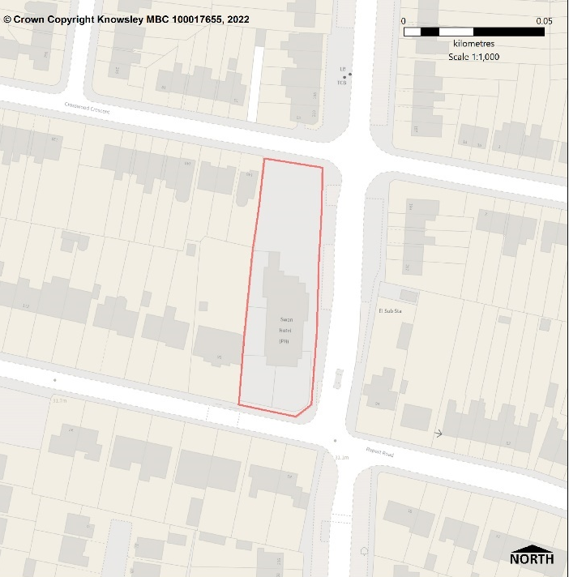

ASSESSMENT OF SUITABILITY, AVAILABILITY AND ACHIEVABILITY
Suitability: Suitable for housing
This site is located in an existing residential area and accessible by different modes of travel. The site abuts Rupert Road and Kingsway, along which there is a bus route. Within several hundred metres of the site are the facilities and services in Huyton villlage, a handful of primary schools and one GP.
Availability: The site is considered to become available in 11-15 years
The necessary infrastructure is available within the locality but there could be legal or ownership issues.
Achievable: Not currently achievable
This site might have uncertain viability due to ownership issues and whilst the site is not considered achievable currently, it is anticipated the issue may be overcome in the future.
Conclusion: The site is Developable
The site is currently in use as a Public House, however, it is in an established residential area with highway access point off Crosswood Crescent. There are no planning policy or known physical constraints that would make the site unsuitable for housing, however, ownership issues mean the site cannot be considered to be suitable for residential dwellings until the period 11-15 years.

Site Reference: K0225
Site Name | St Martin’s Church, Peatwood Avenue, Kirkby
Ward | Cherryfield
Land type | Brownfield
Size (gross) | 0.337 ha.
Net Developable Area | 0.337 ha
Potential Yield | 10 dwellings
Development Trajectory | 11-15 years
Description | Currently in use as a church, vicarage and care centre
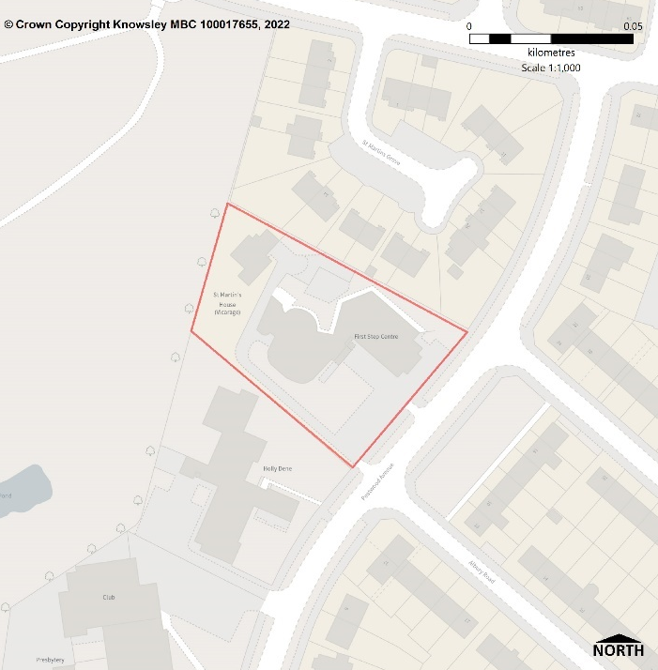

ASSESSMENT OF SUITABILITY, AVAILABILITY AND ACHIEVABILITY
Suitability: Suitable for housing
This site is in an existing residential area and accessible by different modes of travel. It is close to Bewley Drive, along which there is a bus route. The site is close to two primary schools, employment opportunities at Knowsley Industrial Park, and a children’s play provision on Wignall Park greenspace to the rear of the site.
Availability: The site is considered to become available in 11-15 years
The necessary infrastructure is available within the locality but there could be legal or ownership issues.
Achievable: Not currently achievable
This site might have uncertain viability due to ownership issues and whilst the site is not considered achievable currently, it is anticipated the issue may be overcome in the future.
Conclusion: The site is Developable
The site is currently in use as a church, vicarage and care centre. However, it is in an established residential area with highway access point off Peatwood Avenue. There are no planning policy or known physical constraints that would make the site unsuitable for housing, however, ownership issues mean the site cannot be considered to be suitable for residential dwellings until the period 11-15 years.

Site Reference: K0365
Site Name | Former Gas Works, Moss Street, Prescot/Whiston
Ward | Prescot North
Land type | Brownfield
Size (gross) | 1.449 ha.
Net Developable Area | 1.449 ha
Potential Yield | 40 dwellings
Development Trajectory | 0-5 years
Description | Former Gas Works
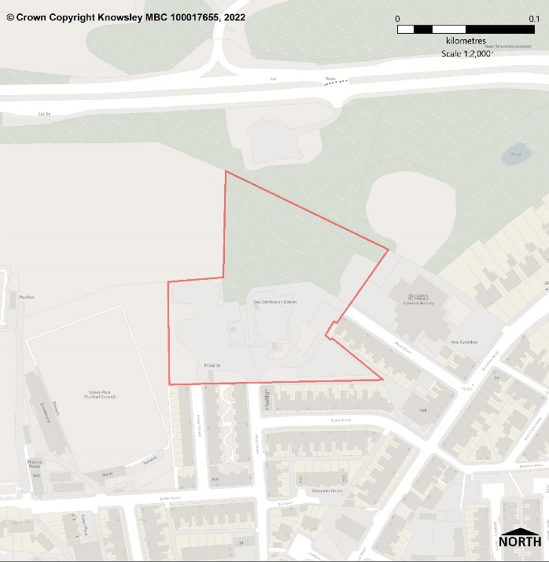

ASSESSMENT OF SUITABILITY, AVAILABILITY AND ACHIEVABILITY
Suitability: Suitable for housing
This site is in an existing residential area and accessible by different modes of travel. It is close to Evans Street and the A58 St Helens Road, along which there are bus routes. Our Lady’s Catholic primary school abuts the site and there are two primary School several hundred metres to the east. The site also offers easy access to the facilities and services in Prescot town centre, which is approximately 200m to the south.
Availability: The site is available
The necessary infrastructure is available within the locality, but
provision to the site will need to be confirmed with the relevant utility companies.
There are no known legal or ownership issues and the site is considered to be available immediately.
Achievable: The site is achievable
There is currently developer interest in this site, and it is likely to be financially viable to develop.
Conclusion: The site is Deliverable
There is currently a planning application pending determination (20/00746/OUT) for the erection of 40 dwellings comprising houses, bungalows and apartments. There are no planning policy or known physical constraints that would prevent the delivery of the site for housing.

Site Reference: K0390
Site Name | Hollow Croft, Stockbridge Village, Stockbridge, Huyton
Ward | Stockbridge
Land type | Greenspace
Size (gross) | 1.83 ha.
Net Developable Area | 1.647 ha.
Potential Yield | 50 dwellings
Development Trajectory | 0-5 years
Description | Urban greenspace
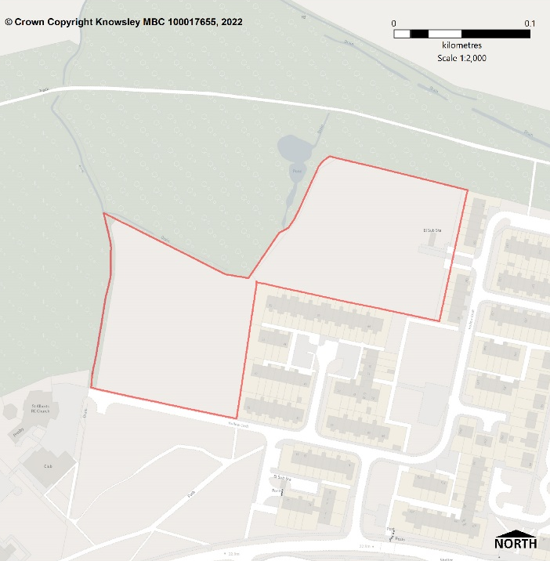

ASSESSMENT OF SUITABILITY, AVAILABILITY AND ACHIEVABILITY
Suitability: Suitable for housing
This site is designated as Urban Greenspace via the Local Plan and currently functions as informal open space. It is in an accessible location, close to bus stops located on Haswell Drive and is approximately 800m from Stockbridge Village district centre including a GP. Meadow Park school and Stockbridge Village primary school are also close by.
Availability: The site is available
The necessary infrastructure is available within the locality and there are no known legal or ownership issues and the site is considered to be available immediately.
Achievable: The site is achievable
The site is likely to be financially viable to develop.
Conclusion: The site is Deliverable
This Council owned site was formerly used for a school, but it is no longer required for education or sporting provision, it is currently vacant and has been identified as surplus by the Council's asset review.

The development of the site for housing would result in an extension of the urban form. However, there are logical and defensible features on the ground to prevent urban sprawl i.e., established woodland to the north and west, St Albert’s Church and Social Club to the west and Haswell Drive to the south. Having said that, the loss of greenspace would need to be assessed. There are no other planning policy or known physical constraints that would make the site unsuitable for housing.

Site Reference: K0403
Site Name | Astley House and Playing Fields, Astley Road, Huyton
Ward | Stockbridge
Land type | Brownfield
Size (gross) | 3.087 ha.
Net Developable Area | 3.087 ha
Potential Yield | 8 dwellings
Development Trajectory | 0-5 years
Description | Vacant land
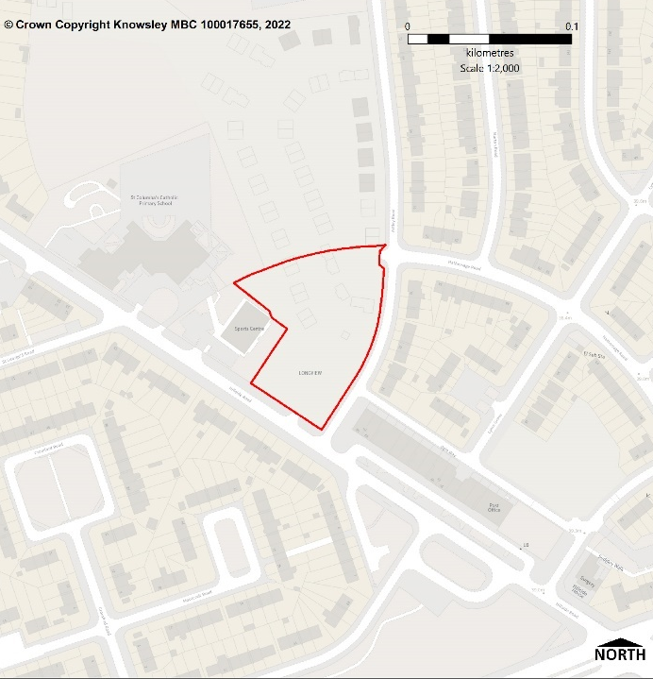

ASSESSMENT OF SUITABILITY, AVAILABILITY AND ACHIEVABILITY
Suitability: Suitable for housing
This site is in a location accessible by different modes of travel and close to bus routes on Knowsley Lane, Hillside Road and the A57 Liverpool Road. St Columbas Catholic primary school abuts the site whilst Knowsley Lane primary school is also close by. Within several metres of the site are the facilities at Hillside Road major local centre, which includes a dental practice, pharmacy, and convenience store.
Availability: The site is available
The site is under construction.
Achievable: The site is achievable
The site is under construction.
Conclusion: The site is Deliverable
The site was used as a school playing field and conference centre, which was subsequently demolished. The site now forms part of a larger site, which benefits from full planning permission for 131 dwellings (20/00099/FUL) and is currently under construction. The K0403 element of the application site will provide 18 dwellings.

Site Reference: K0430
Site Name | Land at Overdene Walk, Kirkby
Ward | Northwood
Land type | Brownfield and greenfield
Size (gross) | 0.269 ha.
Net Developable Area | 0.269 ha.
Potential Yield | 8 dwellings
Development Trajectory | 11-15 years
Description | Vacant land
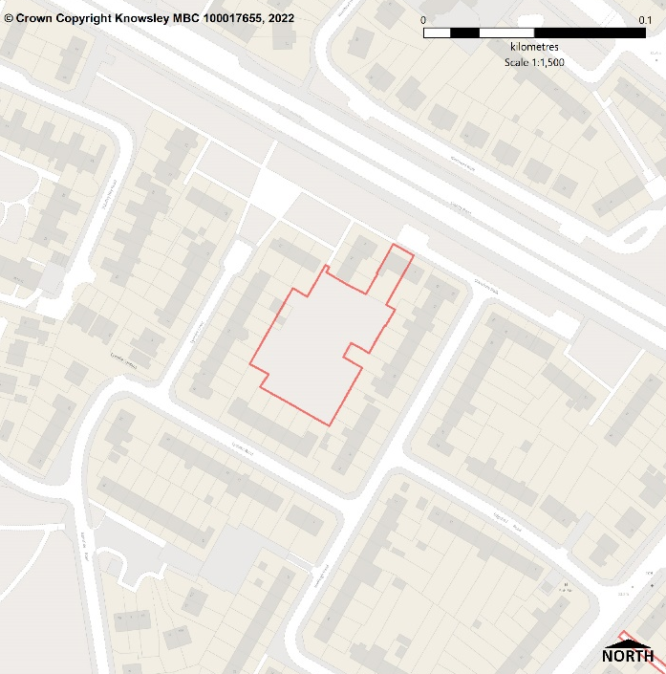

ASSESSMENT OF SUITABILITY, AVAILABILITY AND ACHIEVABILITY
Suitability: Suitable for housing
This council owned site is vacant and overgrown, however, it is located in an established residential area. The site is accessible by different modes of travel and close to a bus route on Brook Hey Drive. Within several hundred metres is Wingate medical centre, St Marie Roman Catholic primary school, Northwood Community primary school and All Saints Catholic high school. The site is also well positioned for access to Knowsley Industrial Park and just under a mile away is the retail and commercial offer in Kirkby town centre.
Availability: The site is considered to become available in 11-15 years
The necessary infrastructure is available within the locality but the availability of the site will require the demolition of 1 dwelling i.e., 3 Overdene Walk.
Achievable: The site is likely to be achievable
This site this might have uncertain viability due to the demolition required to facilitate the delivery of this site.
Conclusion: The site is Developable
There are no planning policy constraints that would make the site unsuitable for housing. However, in order to achieve highway access one property will require demolition therefore the site cannot be considered to be suitable for residential development until the period 11-15 years.

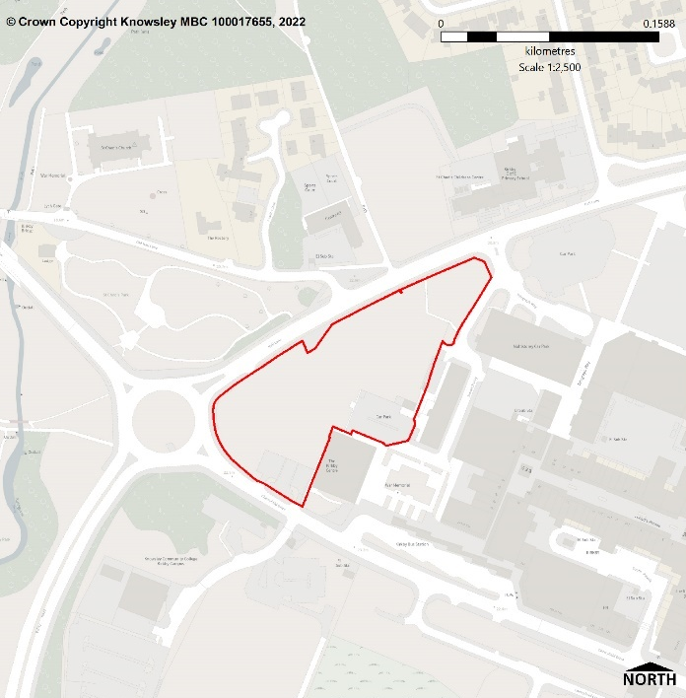
Site Reference: K0700
Site Name | Former Municipal Building and Adjoining Land, Cherryfield Drive, Kirkby
Ward | Whitefield
Land type | Brownfield and greenfield
Size (gross) | 1.35 ha.
Net Developable Area | 1,215 ha
Potential Yield | 36 dwellings
Development Trajectory | 6-10 years
Description | Informal open space and car park

ASSESSMENT OF SUITABILITY, AVAILABILITY AND ACHIEVABILITY
Suitability: Suitable for housing
This site is located in Kirkby town centre as defined in the Local Plan. It is accessible by different modes of travel with Kirkby bus station close by and Kirkby train station approximately 800 metres to the north-west. Within a short distance of the site are the services, facilities and employment opportunities in Kirkby Town Centre including NHS medical centre and pharmacy. Kirkby Church of England Primary School, St Michael and All Angels Primary School and Millbrook Community Primary School are also within a short distance of the site.
Availability: The site is considered to become available in 6-10 years
The necessary infrastructure is considered to be available within the locality, but provision to the site will need to be confirmed with the relevant utility companies. There are no known legal or ownership issues and the site is considered to be available.
Achievable: The site is achievable
There are no known constraints to achievability and the site is likely to be financially viable to develop.
Conclusion: The site is Developable
This Council site comprises a multi-storey car park and informal open space which formerly sited the Knowsley Council municipal services building. With the exception of the car park there are no planning policy or known physical constraints that would make the site unsuitable for housing.

Site Reference: K0701
Site Name | North Huyton, Phase 5
Ward | Stockbridge
Land type | Greenfield
Size (gross) | 9 ha.
Net Developable Area | 6.75 ha
Potential Yield | 263 dwellings
Development Trajectory | 0-15 years
Description | Urban greenspace
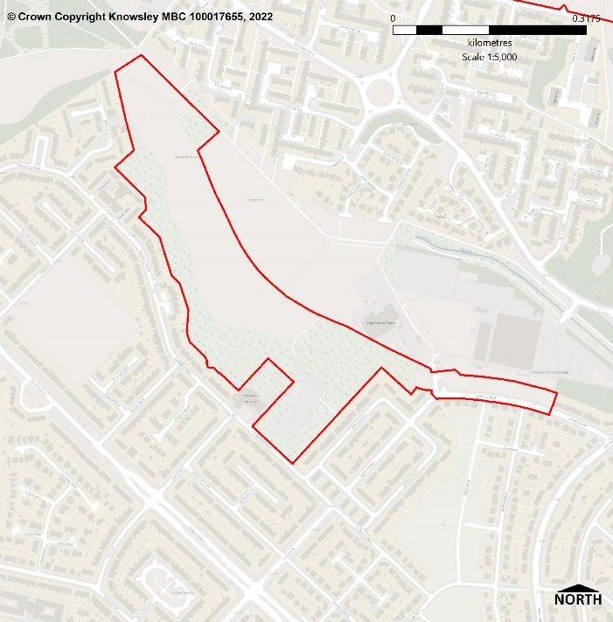

ASSESSMENT OF SUITABILITY, AVAILABILITY AND ACHIEVABILITY
Suitability: Suitable for housing
This site is located in North Huyton Principal Regeneration Area and designated as Urban Greenspace via the Local Plan. This site is located in an accessible location, close to bus stops located on Princess Drive and Stockbridge Lane. Stockbridge Village District Centre including library, Hope Primary School, St Brigid’s Catholic Primary School and Knowsley Community College are all within 500 metres of the site.
Availability: The site is available
The necessary infrastructure is considered to be available within the locality and there are no known legal or ownership issues and the site is considered to be available immediately.
Achievable: The site is achievable
The site is likely to be financially viable to develop.
Conclusion: The site is Deliverable
This Council owned site is currently vacant and functions as informal open space, which is poor quality and deemed surplus to requirements for the area. Consequently, the site is considered to be suitable for residential development. There are no planning policy or known physical constraints that would make the site unsuitable for housing. It is currently forecast that housing will start to be delivered on the site from late 2024/early 2025.

Site Reference: K0702
Site Name | Former St Chad’s Clinic, Kirkby
Ward | Whitefield
Land type | Brownfield
Size (gross) | 0.36 ha.
Net Developable Area | 0.36 ha.
Potential Yield | 50 dwellings
Development Trajectory | 6-10 years
Description | Car park
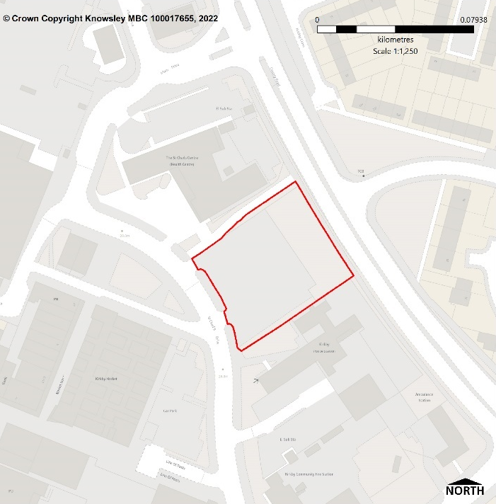

ASSESSMENT OF SUITABILITY, AVAILABILITY AND ACHIEVABILITY
Suitability: Suitable for housing
This site is located in Kirkby Town Centre and accessible by different modes of travel. The site is close to Kirkby bus station, whilst on the doorstep are the services, facilities and employment opportunities in Kirkby Town Centre including retail and commercial offer, NHS medical centre, pharmacy and Primary School provision.
Availability: The site is considered to become available in 6-10 years
The necessary infrastructure is considered to be available within the locality and there are no known legal or ownership issues and the site is considered to be available. However, market interest appears to be currently low.
Achievable: The site is achievable
The site is likely to be financially viable to develop, particularly if higher density housing is provided in the region of 50 apartment dwellings.
Conclusion: The site is Developable
This Council owned site is currently in use as a car park but its town centre location, close to amenities makes it suitable for residential use in the form of apartments for Town Centre living, extra care or similar. There are no planning policy or known physical constraints that would make the site unsuitable for housing.

Site Reference: K0703
Site Name | Huyton Fire and Ambulance Station
Ward | St. Gabriels
Land type | Brownfield
Size (gross) | 0.95 ha.
Net Developable Area | 0.95 ha.
Potential Yield | 50 dwellings
Development Trajectory | 0-5 years
Description | Vacant land and ambulance station
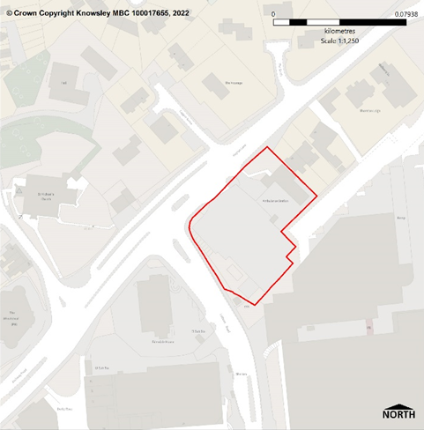

ASSESSMENT OF SUITABILITY, AVAILABILITY AND ACHIEVABILITY
Suitability: Suitable for housing
This Council owned site is located in Huyton Town Centre and accessible by different modes of travel. The site fronts onto Huyton Lane along which there is a bus route and it is approximately 400 metres from Huyton bus station and 600 metres from Huyton train station. The site is also close to the services, facilities and employment opportunities in Huyton Town Centre including retail and commercial offer, NHS walk-in centre and Primary School provision.
Availability: The site is available
The necessary infrastructure is considered to be available within the locality, there are no known legal or ownership issues and the site is considered to be available immediately.
Achievable: The site is achievable
The site is likely to be financially viable to develop.
Conclusion: The site is Deliverable
This site comprises the site of the former Huyton Fire Station, which is now vacant, and Huyton Ambulance Station, which is currently operational but it is not seen as a constrain to the site delivering residential development in the next 5 years.

There is currently a planning application pending determination (ref. 23/00075/FUL) for the development of 53 retirement living apartments. Consequently, there are no planning policy or known physical constraints that would make the site unsuitable for housing.

Site Reference: K0704
Site Name | Bewley Drive, Kirkby
Ward | Cherryfield
Land type | Greenfield
Size (gross) | 0.59 ha.
Net Developable Area | 0.531
Potential Yield | 15 dwellings
Development Trajectory | 6-10 years
Description | Urban greenspace
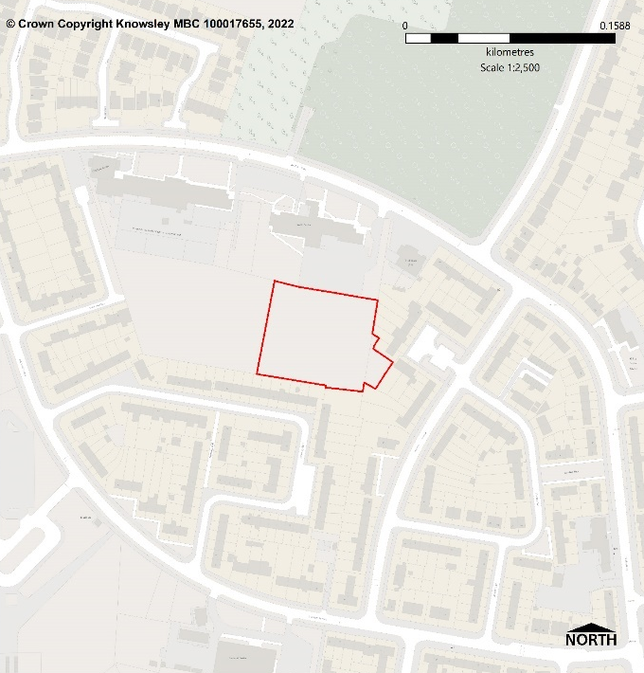

ASSESSMENT OF SUITABILITY, AVAILABILITY AND ACHIEVABILITY
Suitability: Suitable for housing
This site is designated as Urban Greenspace via the Local Plan and currently functions as an informal open space. However, if it is proven that there is a surplus of greenspace in the area the site is considered to be suitable for residential dwellings.
Availability: The site is considered to become available in 6-10 years
The necessary infrastructure is considered to be available within the locality and there are no known legal or ownership issues and the site is considered to be available.
Achievable: The site is achievable
The site is likely to be financially viable to develop.
Conclusion: The site is Developable
This site in Council ownership is vacant but was formerly used as primary school playing fields however, the site is no longer required for education or sporting provision. The loss of greenspace would need to be assessed, otherwise there are no other planning policy or known physical constraints that would make the site unsuitable for housing. In the absence of developer interest in the site and an assessment of the loss of greenspace the site is considered developable but not deliverable at this time.

Site Reference: K0705
Site Name | Land south of Cherryfield Drive, Kirkby
Ward | Cherryfield
Land type | Greenfield
Size (gross) | 22.54 ha.
Net Developable Area | 16.905 ha.
Potential Yield | 614 dwellings
Development Trajectory | 0-10 years
Description | Urban greenspace
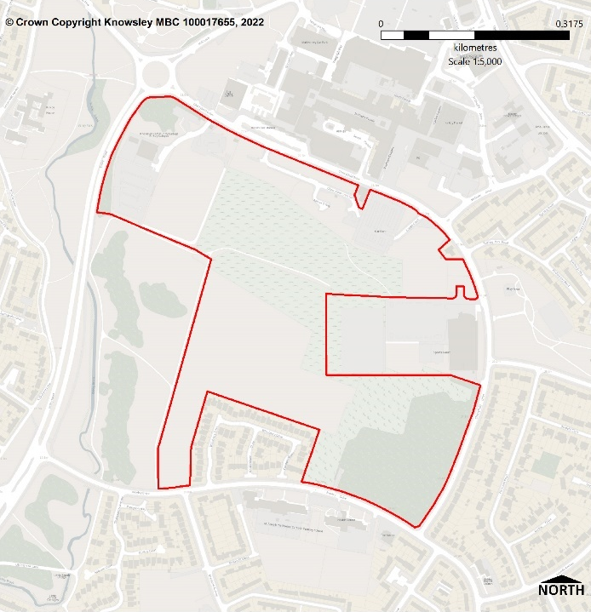

ASSESSMENT OF SUITABILITY, AVAILABILITY AND ACHIEVABILITY
Suitability: Suitable for housing
This site is designated as Urban Greenspace via the Local Plan and it is located close to Kirkby Town Centre. The site is accessible by different modes of travel. The site is close to Kirkby bus station and Kirkby train station whilst nearby are the services, facilities and employment opportunities in Kirkby Town Centre including retail and commercial offer, NHS medical centre and Primary School provision.
Availability: The site is available
The necessary infrastructure is considered to be available within the locality, but provision to the site will need to be confirmed with the relevant utility companies. There are no known legal or ownership issues and the site is considered to be available immediately however the development is likely to be completed over the next 10 years.
Achievable: The site is achievable
There is current developer interest in this site and it is likely to be financially viable to develop. A scoping opinion has been submitted to the Council for residential development comprising 720 dwellings and an 89 unit extra care facility.
Conclusion: The site is Deliverable
This Council owned site was formerly used by Knowsley Community College and also sited a primary school and associated playing fields. However, the site is no longer required for education or sporting provision and is currently vacant. The greenspace is surplus to the provision needed in the area and there are no other planning policy or known physical constraints that would make the site unsuitable for housing.
Site Reference: K0706
Site Name | Boundary Hotel, Pilch Lane, Huyton, Liverpool, L14 0JG
Ward | Swanside
Land type | Brownfield
Size (gross) | 0.725 ha.
Net Developable Area | 0.6525
Potential Yield | 20 dwellings
Development Trajectory | 0-5years
Description | Vacant land.
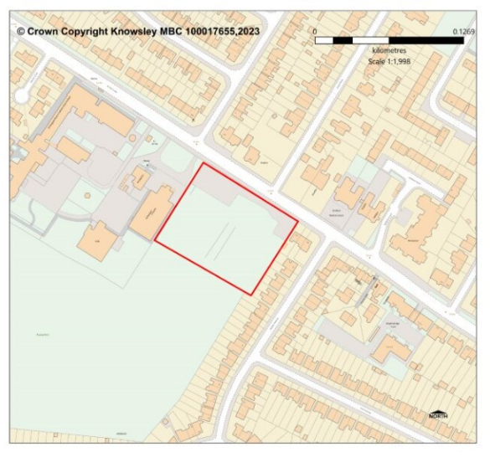

ASSESSMENT OF SUITABILITY, AVAILABILITY AND ACHIEVABILITY
Suitability: Suitable for housing
This site is located in an existing residential area and accessible by different modes of travel. The site abuts Pilch Lane, along which there is a bus route. The site adjoins St Margaret Mary’s RC Church and St Margaret Mary’s Catholic Infant School is also close by. The site is within several hundred metres of facilities and services including pharmacy and surgery. Although the site is not allocated in the Local Plan there is a know aspiration to deliver a health care facility on it which would reduce the potential yield. Its allocation in the SHLAA would not affect the potential of a medical facility being delivered on the site were a planning application submitted in the future.
Availability: The site is available
The necessary infrastructure is considered to be available within the locality, but provision to the site will need to be confirmed with the relevant utility companies. There are no known legal or ownership issues and the site is considered to be available immediately however the development is likely to be completed over the next 10 years.
Achievable: The site is achievable
The site is likely to be financially viable to develop.
Conclusion: The site is Deliverable
This previously developed site has been cleared of any built structures and is located within a sustainable location. There are no other planning policy or known physical constraints that would make the site unsuitable for housing.

Site Reference: K0707
Site Name | Fallows Way, Whiston, Liverpool, L35 1RZ
Ward | Whiston South
Land type | Brownfield
Size (gross) | 0.32 ha
Net Developable Area | 0.32 ha
Potential Yield | 10 dwellings
Development Trajectory | 0-5years
Description | Hotel car park.
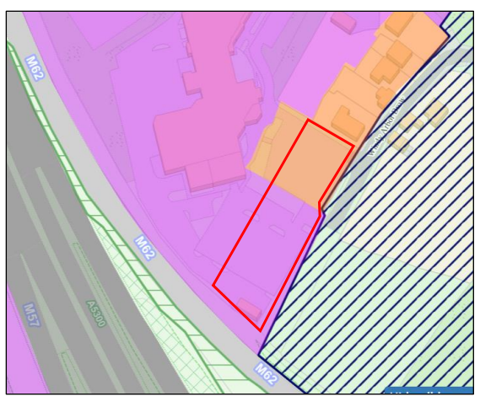

ASSESSMENT OF SUITABILITY, AVAILABILITY AND ACHIEVABILITY
Suitability: Suitable for housing
This site is located in both a primarily industrial area and a primarily residential area in the Local Plan. The site is in an accessible location and is within easy access of Windy Arbor Road, along which there is a bus route. The site is close to a range of facilities in Whiston, the Halsnead Garden Village and it is located on the periphery of Huyton Business Park which offers employment opportunities.
Availability: The site is available
The necessary infrastructure is considered to be available within the locality. There are no known legal or ownership issues and the site is considered to be available immediately.
Achievable: The site is achievable
The site is likely to be financially viable to develop.
Conclusion: The site is Deliverable
This site currently forms part of the operational land of ‘Village Hotel Liverpool’ however the site is considered surplus to requirements. The site is partly located within a primarily industrial area but it is considered that residential development would have no impact on employment uses or the wider industrial area. It is also considered the proposal would not result in an unacceptable loss of industrial land because the site has been lost to the hotel use already. There is no other planning policy or known physical constraints that would make the site unsuitable for housing development.

Appendix E: Housing Commitments Forecast

Appendix E is available to view as a separate document on the Council’s website.

Appendix F: Local Plan Housing Allocations Forecast

Appendix F is available to view as a separate document on the Council’s website.

Appendix G: SHLAA Sites Forecast

Appendix G is available to view as a separate document on the Council’s website.

For more information log on to
www.knowsley.gov.uk/LocalPlan

You can also get this information in other formats. Please phone Customer Services on 0151 443 4031 or email customerservices@knowsley.gov.uk



Copyright © 2023 Metropolitan Borough of Knowsley

The Planning Practice Guidance (MHCLG), Housing and economic land availability assessment, Paragraph: 009 Reference ID: 3-009-20190722.
Planning Practice Guidance (MHCLG), Housing and economic land availability assessment, paragraph 028 Reference ID: 3-028-20180913

